

CHC2DST – Version 2.5 Release Notes

Table of Contents
Enhancements 3
1. Edit GP details on case 3
2. Indicate Notes exist on a case 4
3. “Copy Patient Address” button 5
4. Improved logic on question "is the patient currently in an acute hospital?" 6
5. Header selection - Workflow column visible by default 7
6. New “Fast Track” tab in the back-office 8
7. Don't show Fast Track tab if user doesn't have permission to view it 9
8. Digital Fast Track Tool ability to record actual referring clinician 10
9. New Security Permissions for “Other Cases” and “Reviews” tabs 11
Bug Fixes 12

Enhancements

Edit GP details on case

Request from Sunderland CCG.
On the “Summary” tab for a case, where a user has the new Security Permission “Can edit General Practitioner details” set, this will allow them to edit the GP Practice and GP name:
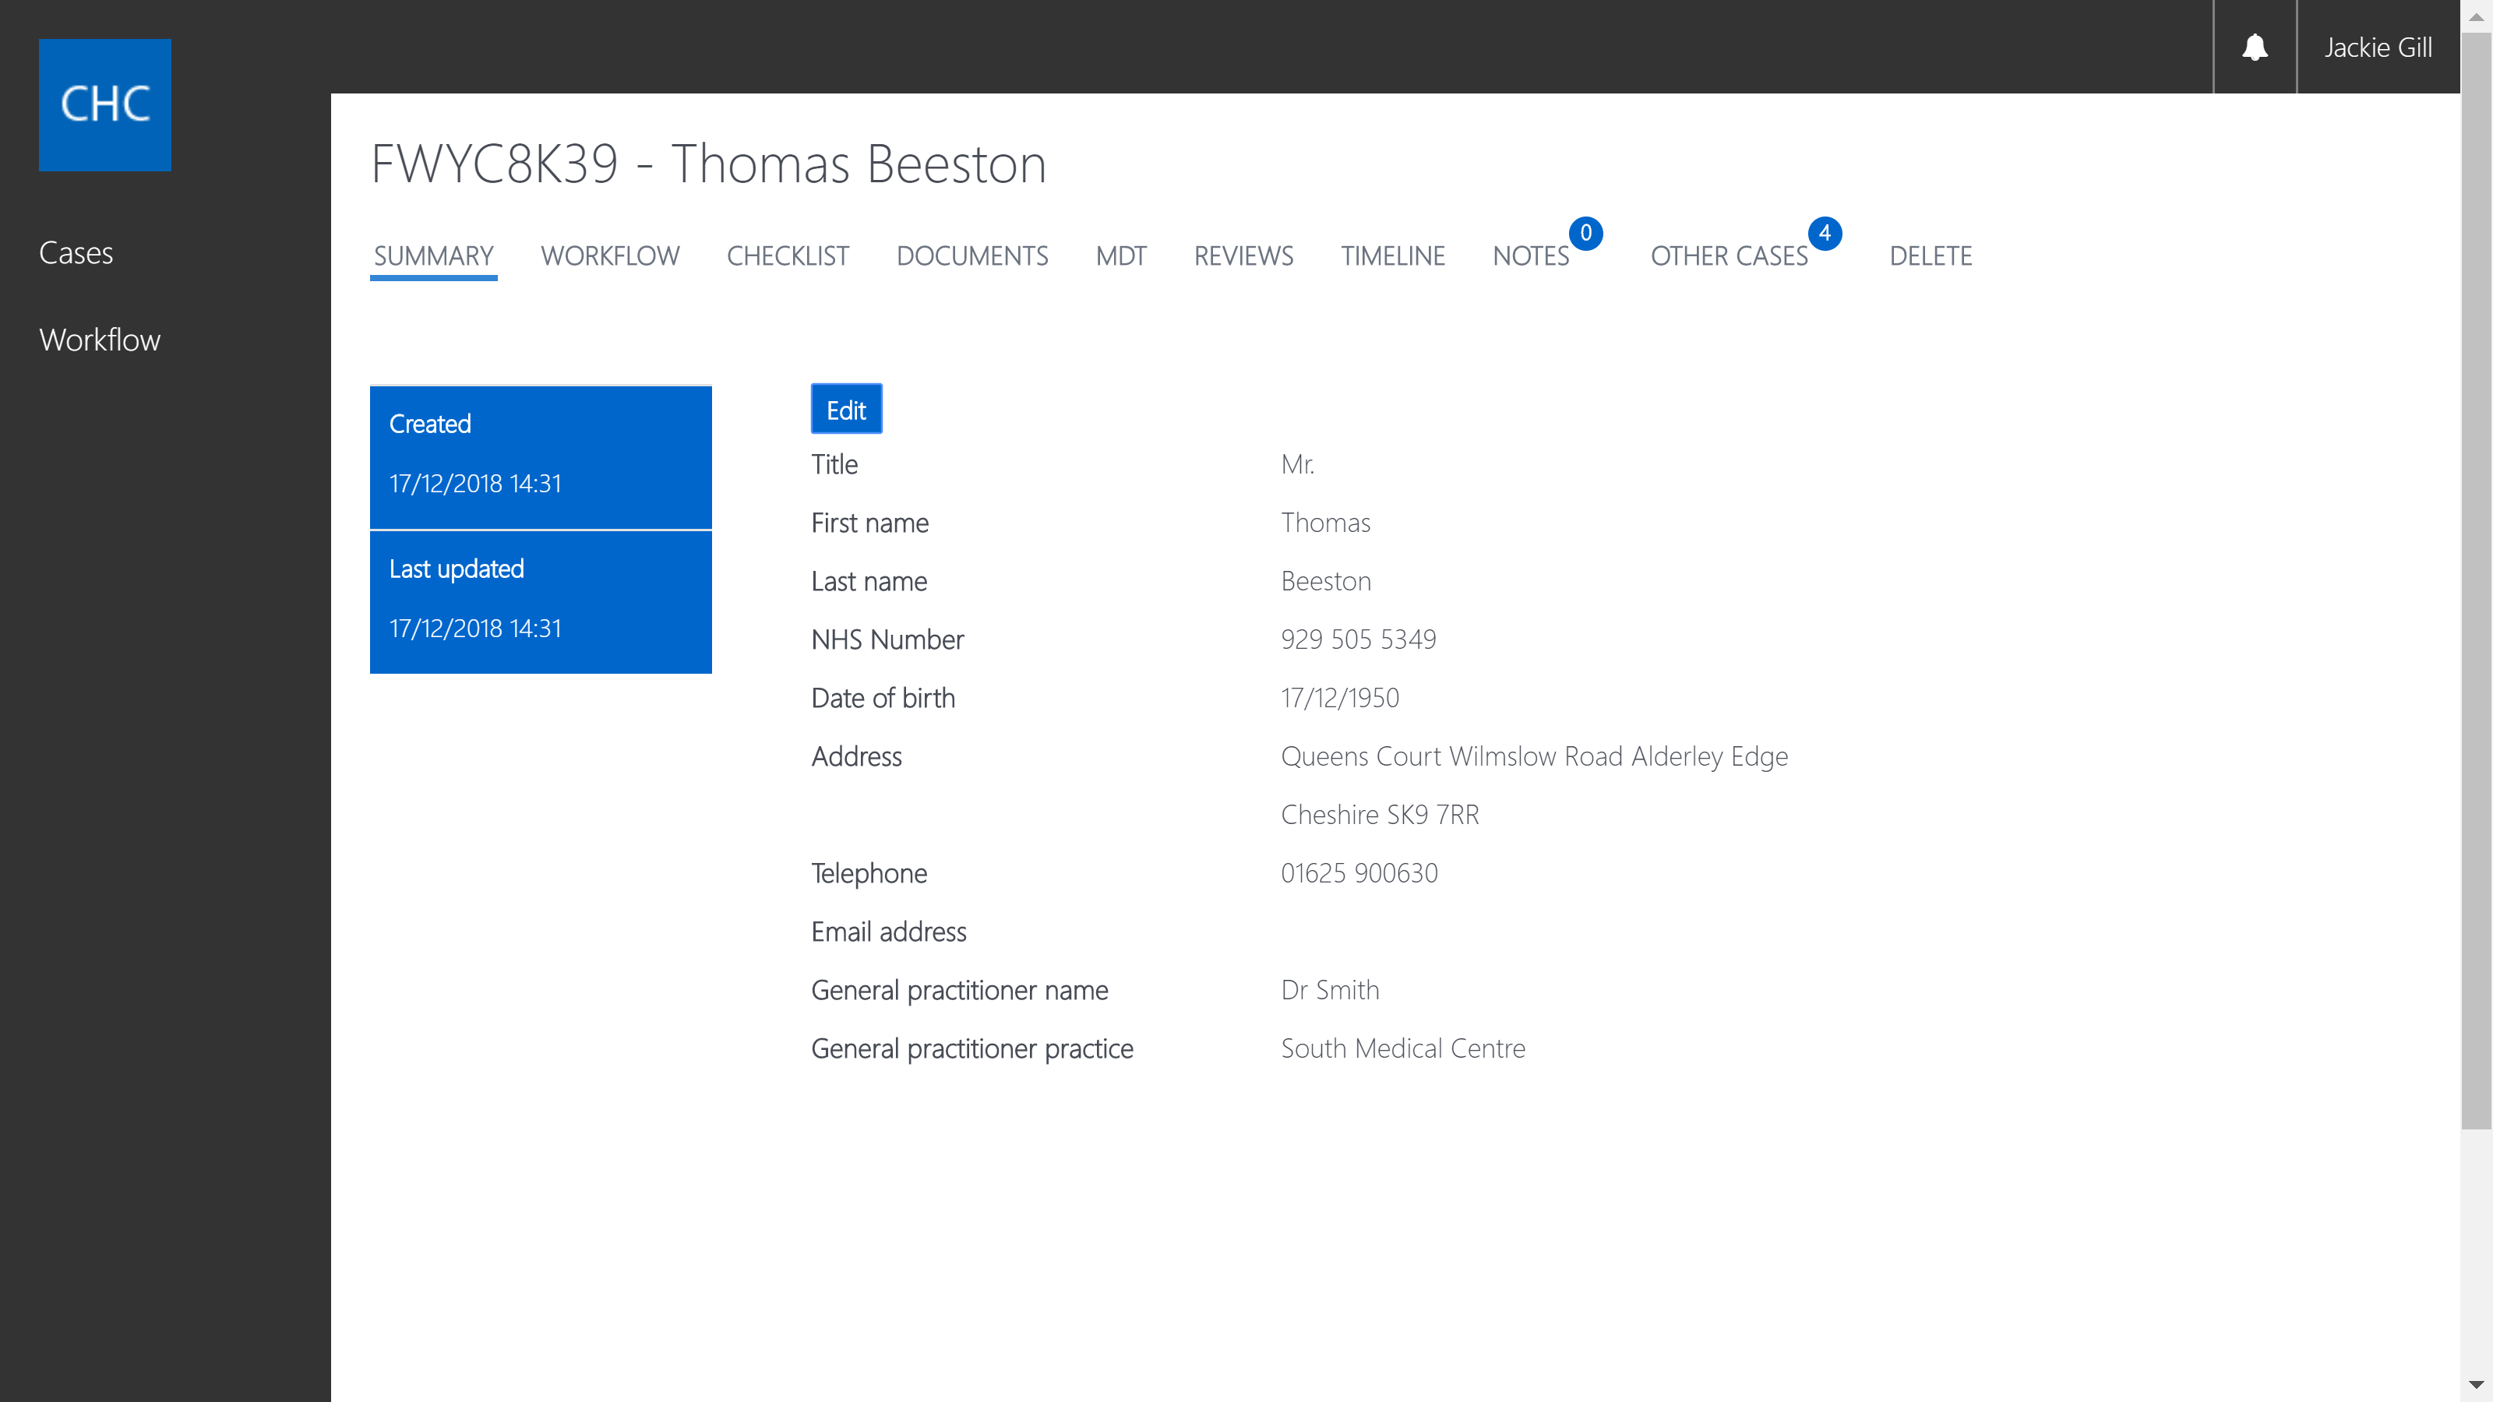
This function is controlled in Settings – Security Group – Manage Permissions – “Can edit General Practitioner details”:
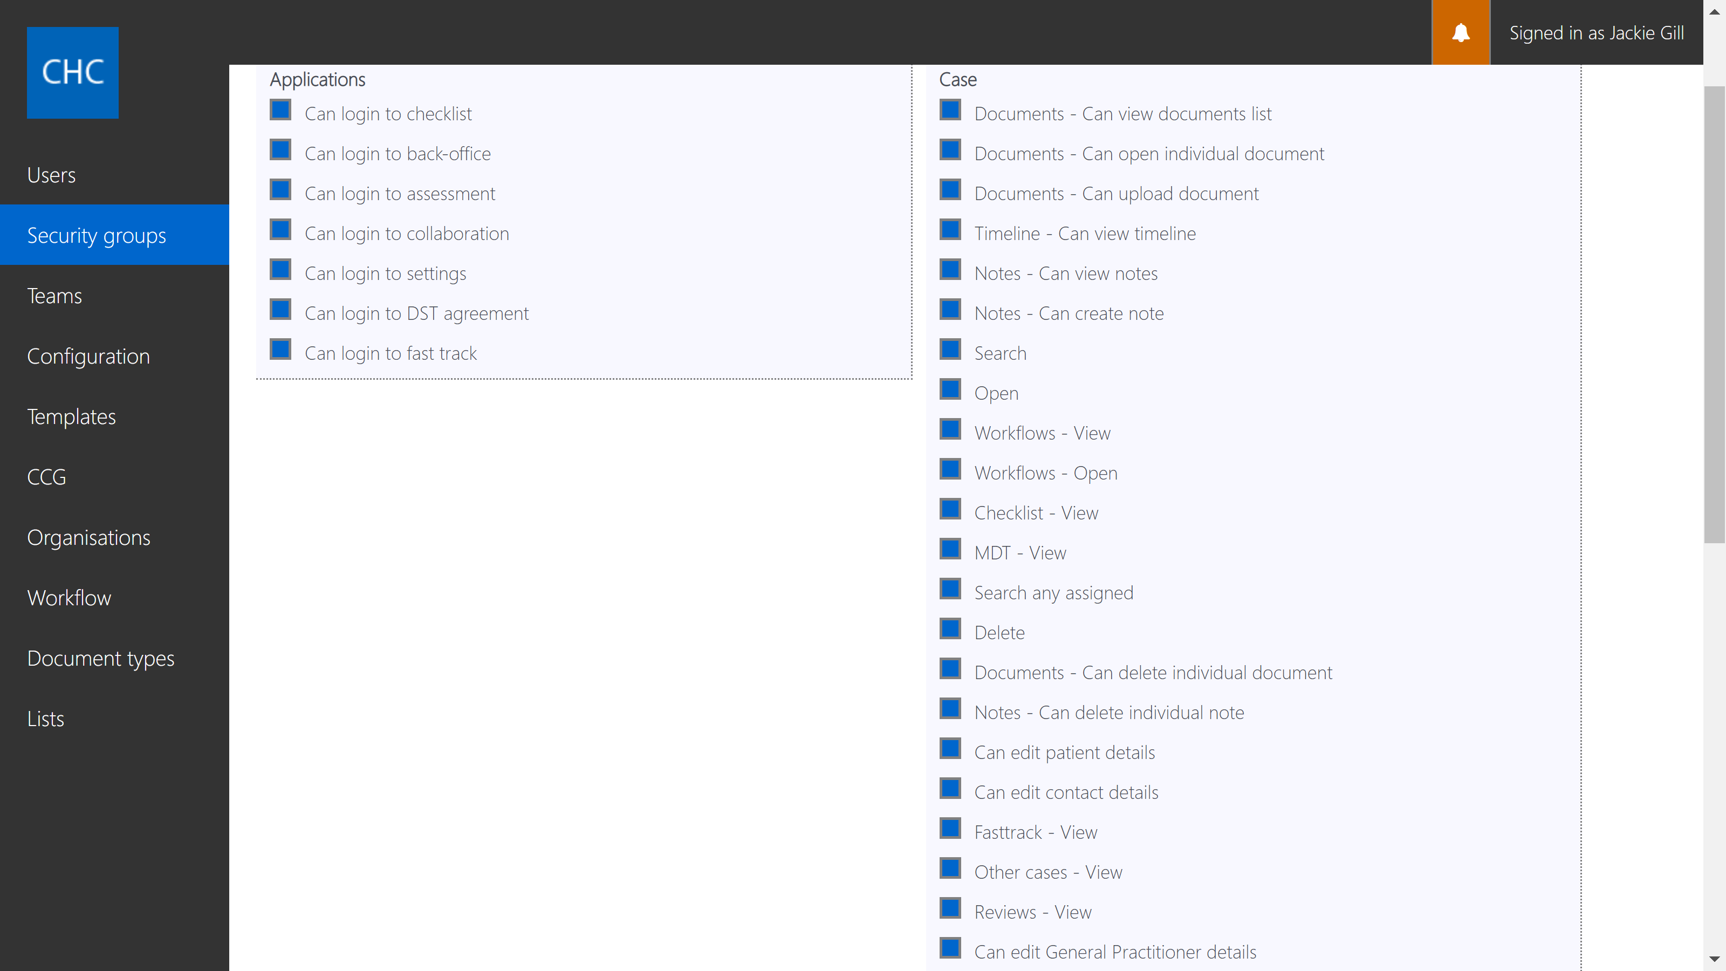

Indicate Notes exist on a case

On the Notes tab indicate with a number how many Note entries exist, which will then alert users to the fact that Notes exist on the case without blindly clicking on the Notes tab to check:
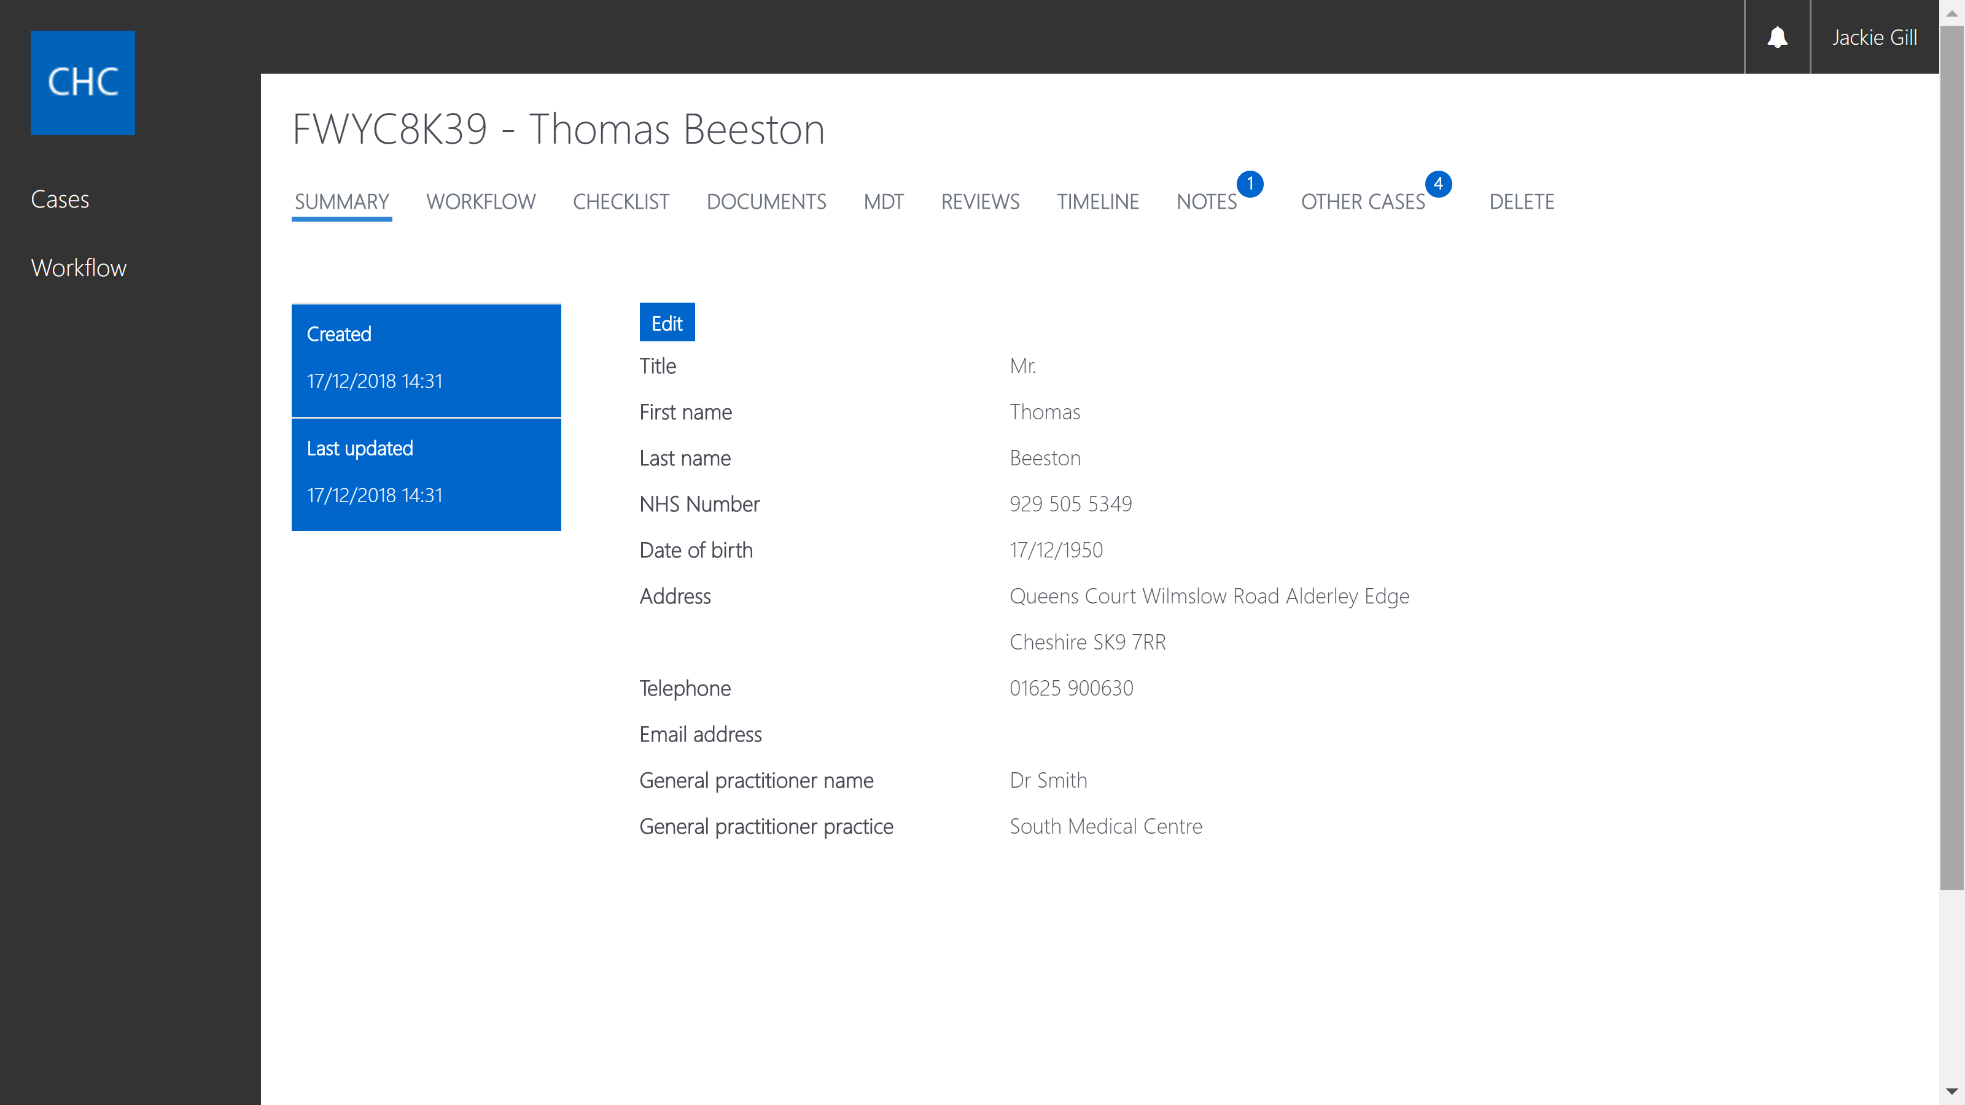

“Copy Patient Address” button

On the Checklist and Fast Track forms have a button to copy the patient’s address so that the user doesn't have to type the same address in twice on one page of the form:

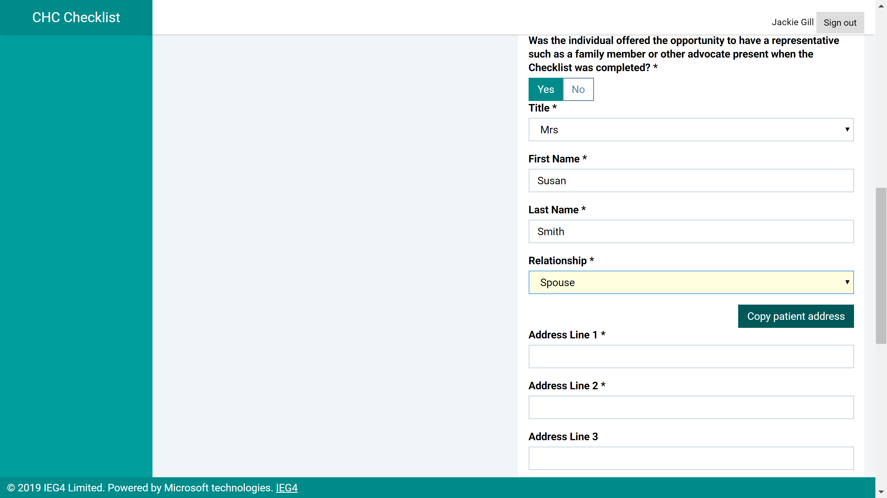

Improved logic on question "is the patient currently in an acute hospital?"

On eChecklist where it asks “is the patient currently at their permanent address?” where the answer is “Yes” remove the question “is the patient currently in an acute hospital?”
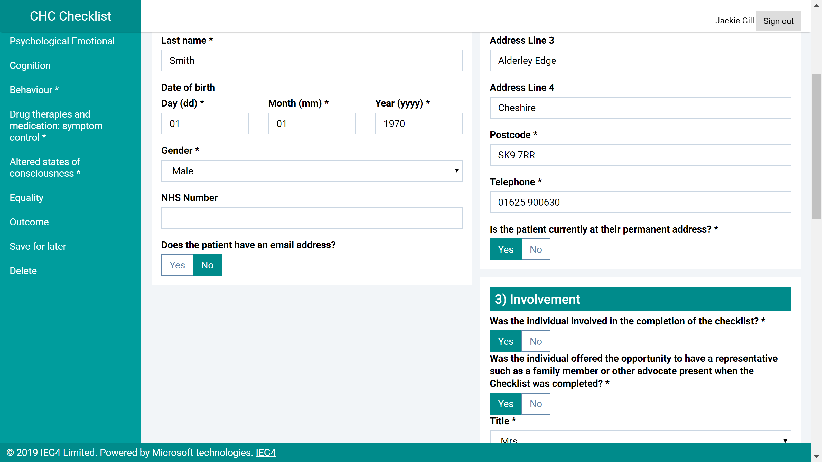

Header selection - Workflow column visible by default

Requested by Dorset CCG.
Could the 'Workflow' header be added to the headers at the top of cases and workflow in the back-office section by default rather than having to manually select it every time. This would aid those managing cases between Fast track and CHC to make them easily identifiable.

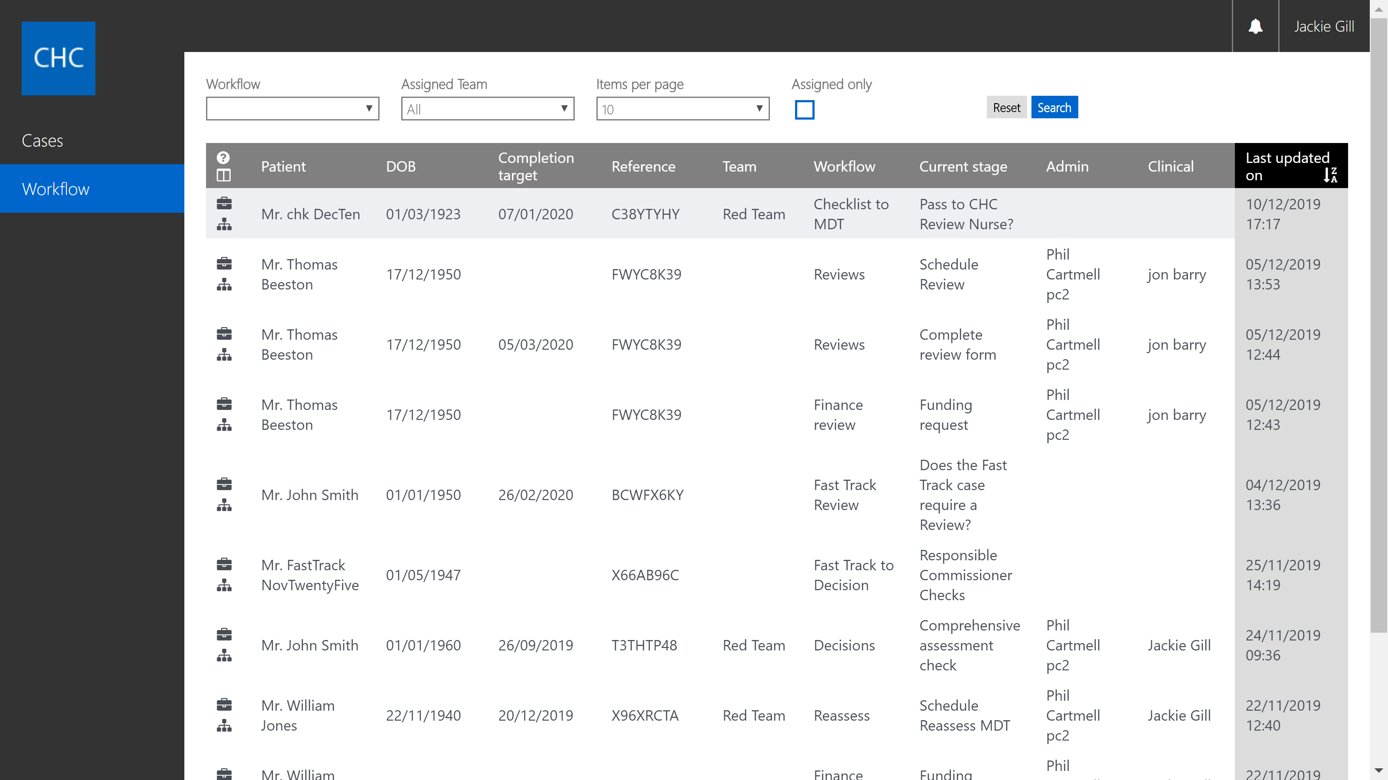

New “Fast Track” tab in the back-office

To display data from the submitted Digital Fast Track form:

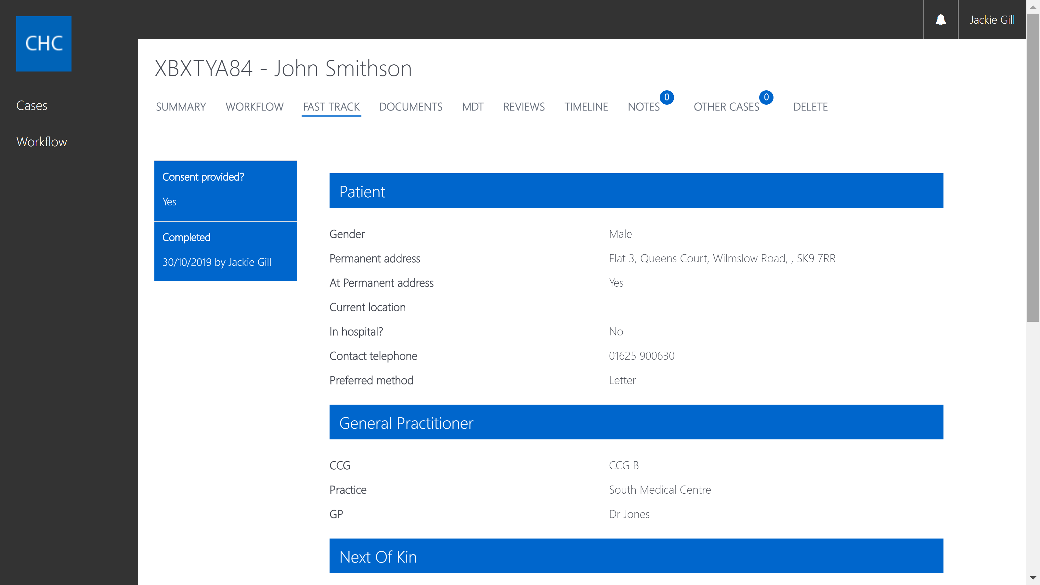

Don't show Fast Track tab if user doesn't have permission to view it

New Security Group permission “Fasttrack – View” has been added so you can control which users can view the Fast Track tab:

Digital Fast Track Tool ability to record actual referring clinician

This allows the user completing the digital form to record if someone else was actually the referring clinician i.e. of they are filling in the digital form on someone else’s behalf.
Where the answer to the question “Are you the referring clinician?” is “No” then a second question appears “Use as referring clinician in PDF?”. Where the answer is “Yes” those details will be included in the PDF of the Fast Track Pathway Tool. Where the answer is “No” then the user’s details will be included.
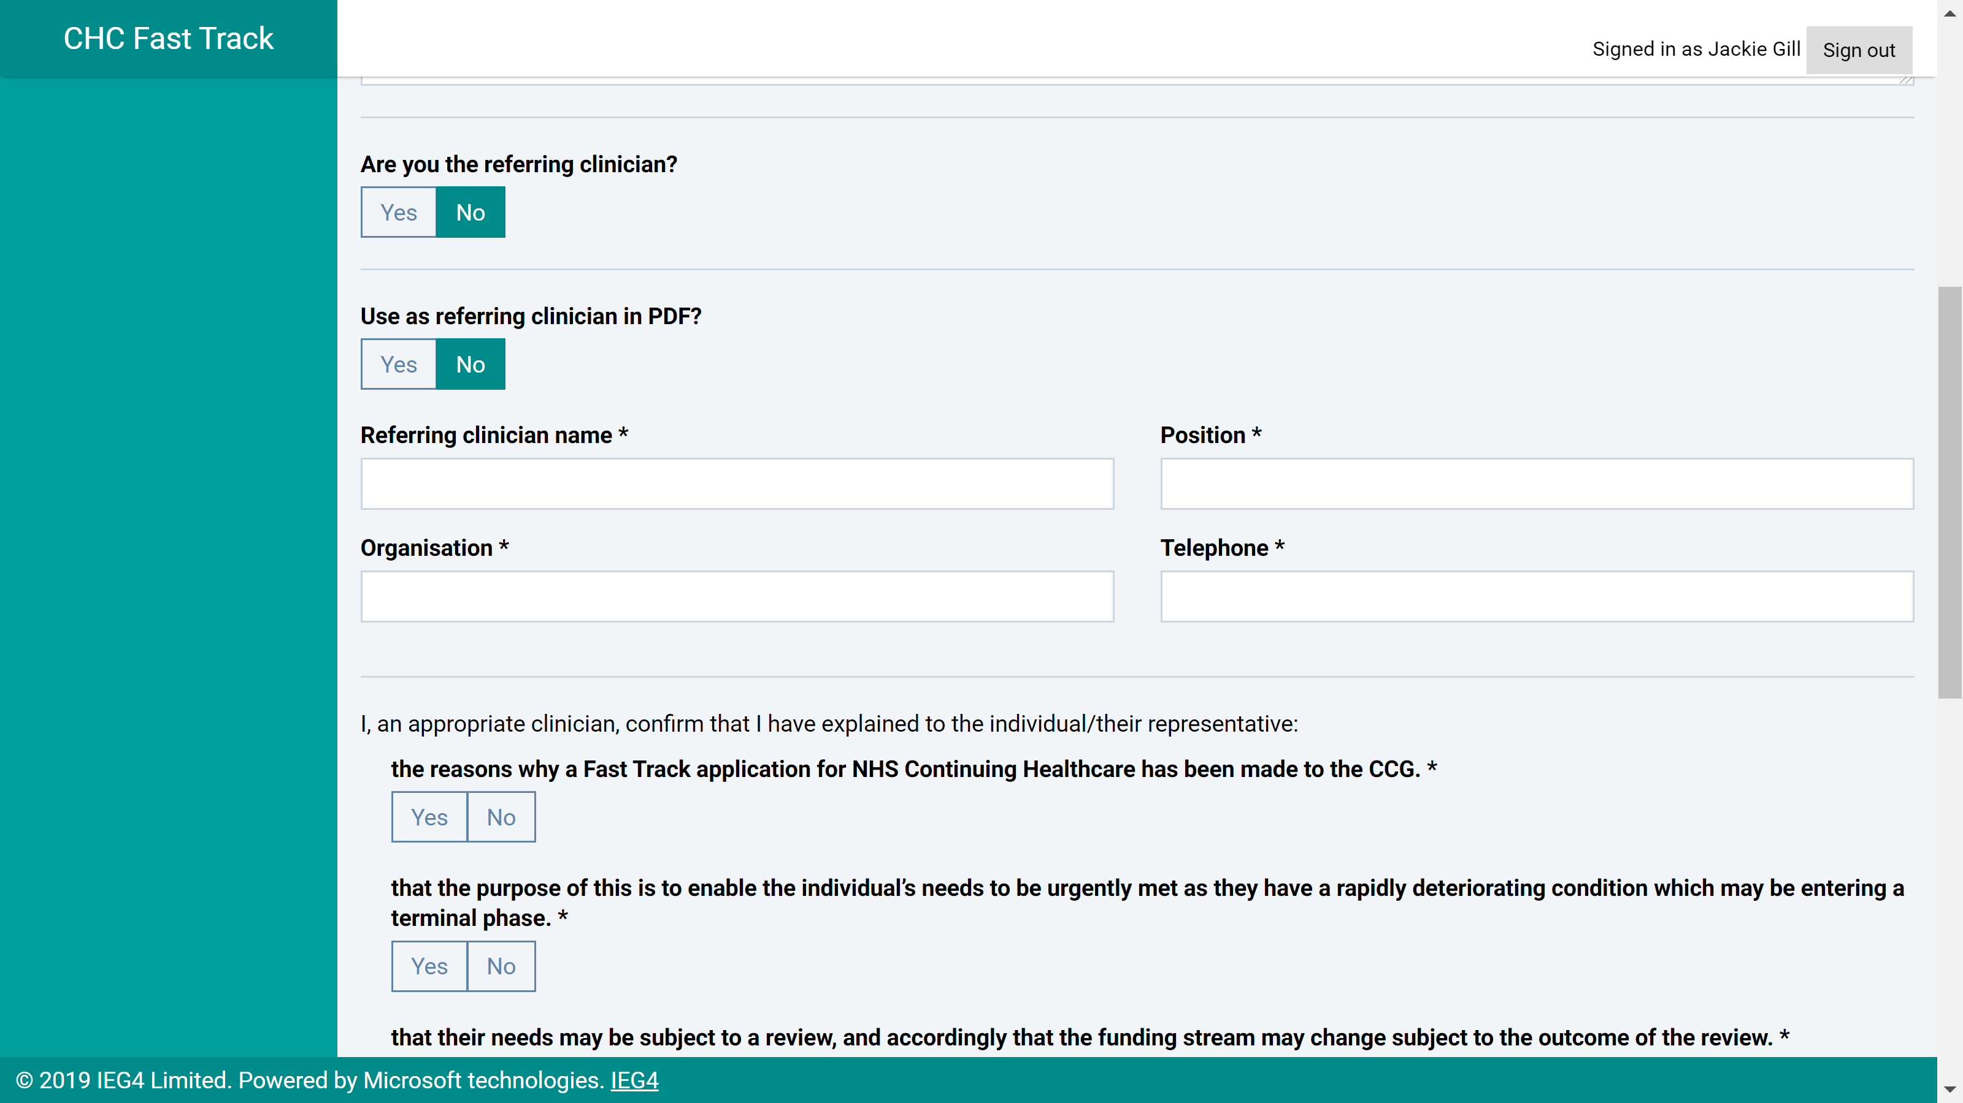
The visibility of those questions is controlled by Security Group Permission “Can override PDF clinician details”:
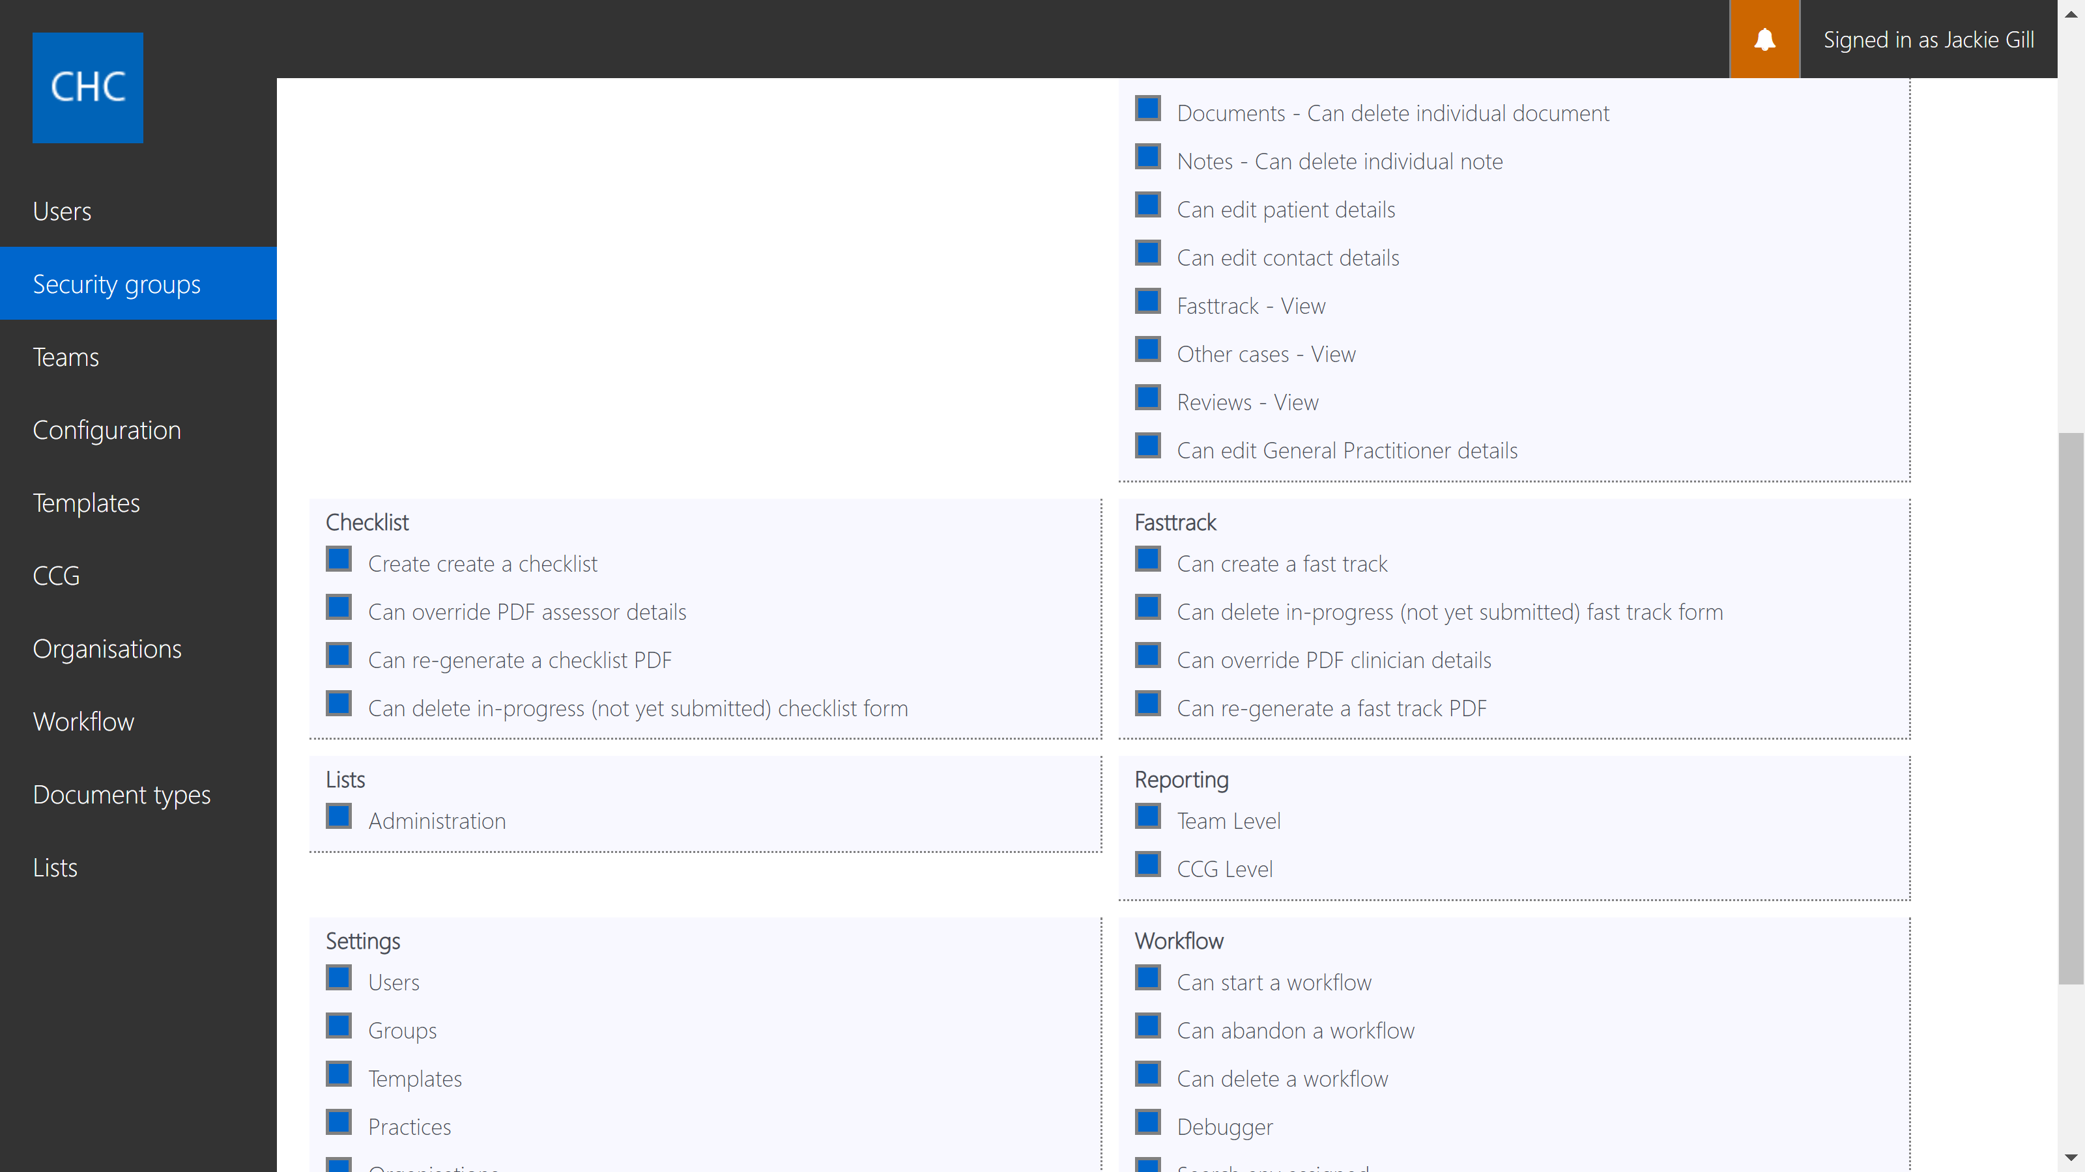

New Security Permissions for “Other Cases” and “Reviews” tabs

There are two new Security permissions that control which users can view the “Other Cases” and “Reviews” tabs in the back-office:
- Other Cases - View
- Reviews - View

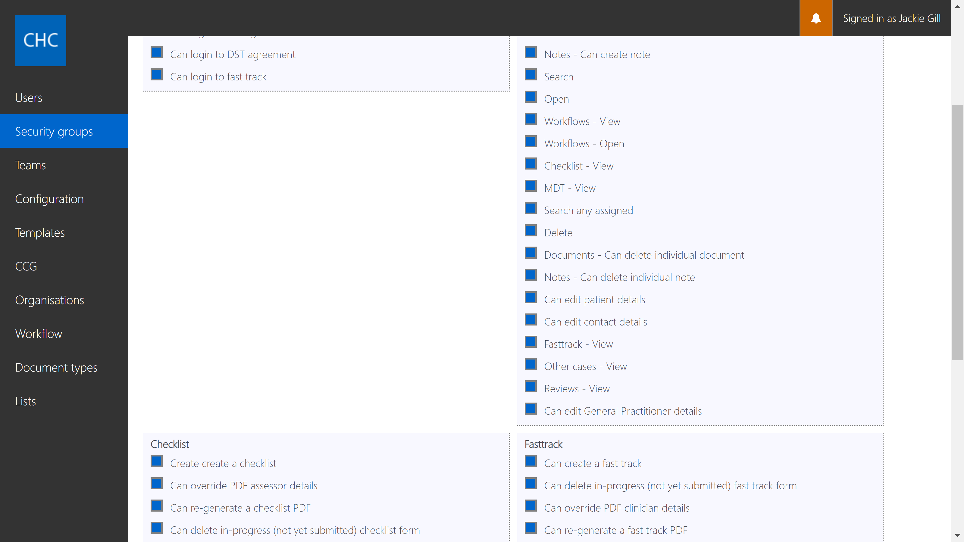

Bug Fixes

- NHS number change causing patient contact details, representative details and equalities data to be lost.

- "Document Type" Validation - In Settings – Document Types. We need to ensure that Document Type names can only have 0-9, a-z and a space.

- Spelling error 'Their is an error in the participants provided' – reported by Dorset CCG

- Case user permission for Notes count bug.

- Rewind workflow permissions bug. requires abandon workflow too.

- Gender option of 'trans' not available in all UIs – reported by Cheshire CCGs

- Prevent the user from selecting themselves for a second opinion. In the Decisions Workflow, at the "second opinion required" stage prevent the user from selecting themselves for the second opinion as this is not logical.

- GP list to be ordered alphabetically in drop-down list in both eChecklist and the BackOffice - requested by Sunderland CCG.

