Care Package Uplifts – Release Notes – March 2026
The Digital CHC system enables care package services to have:
- Standard Rates
- Commissioned Prices
- Ad-hoc Prices
Depending on the pricing used there are different ways that price uplifts can be recorded.
- Standard Rate Uplifts
Standard Rates are recorded in Directory of Services on the Standard Rates screen:
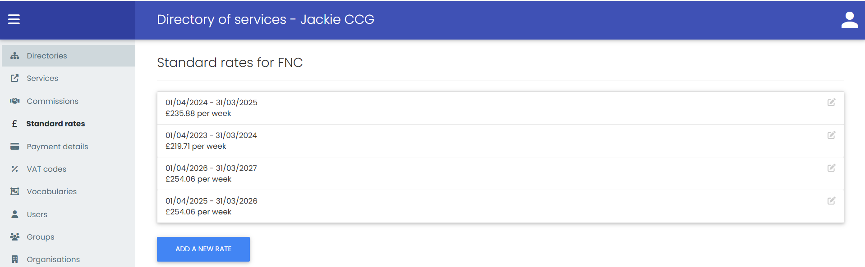
Where the new Standard Rate is not yet known you must add in the existing Standard Rate for the new financial year.
The system will only generate service confirmations that cover the date range that a Standard Rate has been added for. Hence why you need to add a new Standard Rate for the new financial year prior to the start date of that new financial year.
Once the new rate is known the existing Standard Rate can be edited.
Payment Schedules to generate shortfall for backdated Standard Rates
Finance Module – Payment Schedules
Once the new Standard Rate has been added you then need to generate a new “Standard Rate Uplift Schedule” from the Payment Schedules screen:
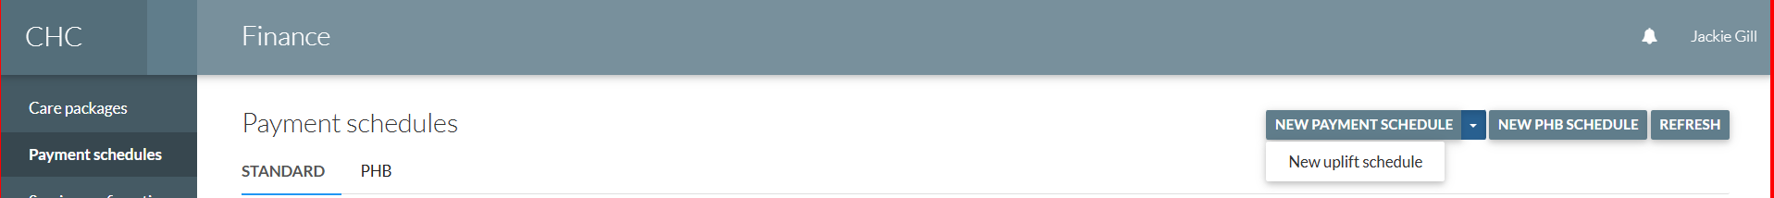

Select the new Standard Rate that has been added for the financial year:
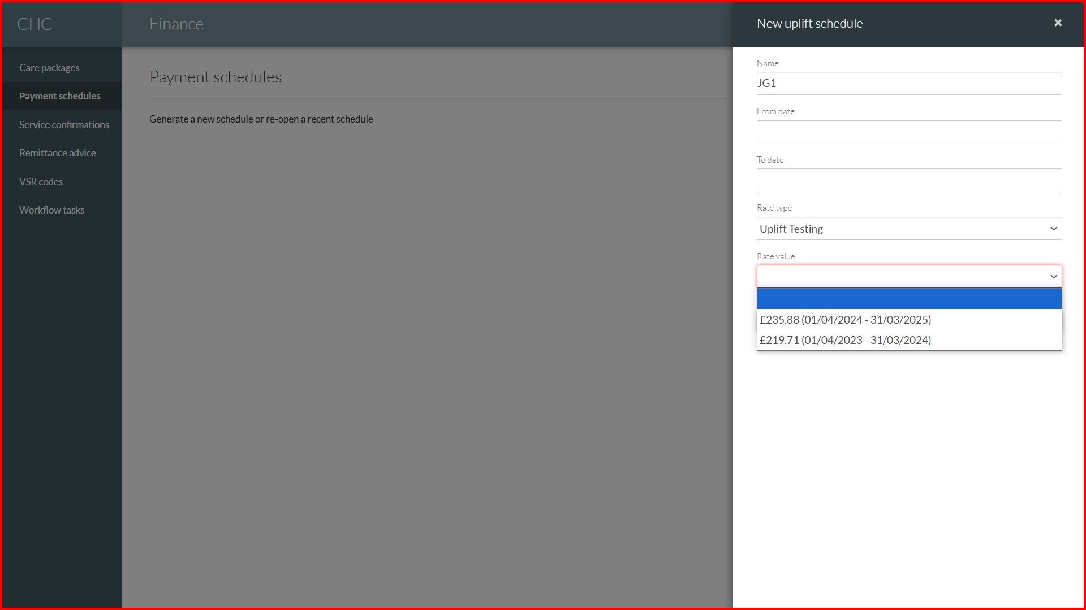
The system will then generate payment transactions to pay the difference between what has been paid already and the new Standard Rate:
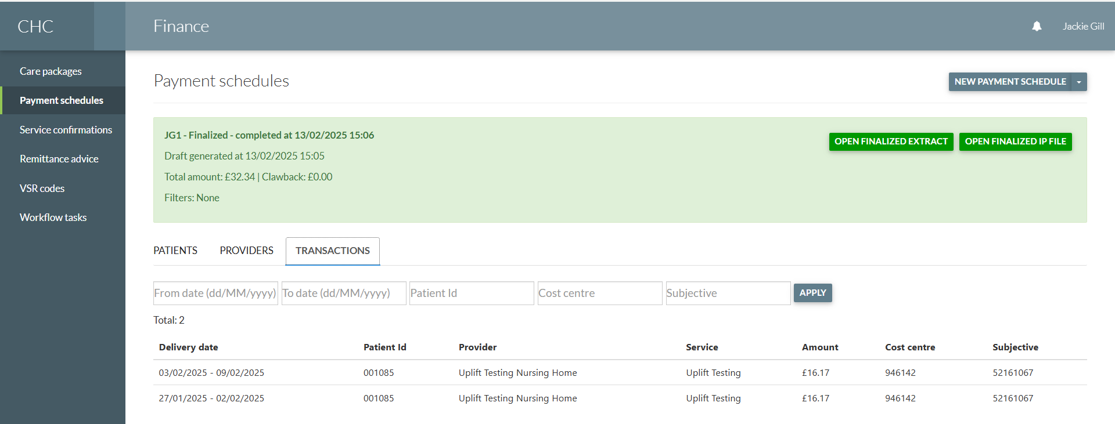
When looking at the service confirmations on the care package the system will clearly display where there has been more than one payment for the week:
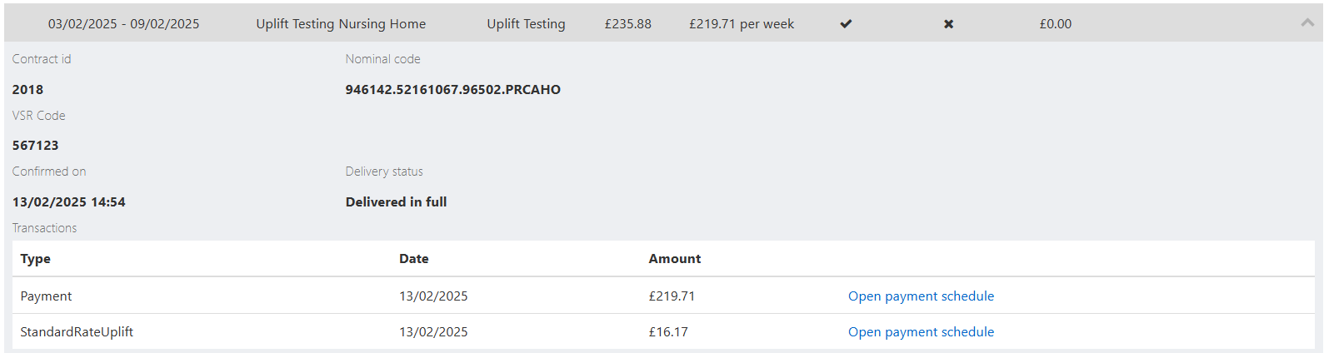
There is a new Transaction type “StandardRateUplift” so it’s clear.
- Bulk Add Commissions (Contracted Costs)

Click on the “Bulk Add” button:

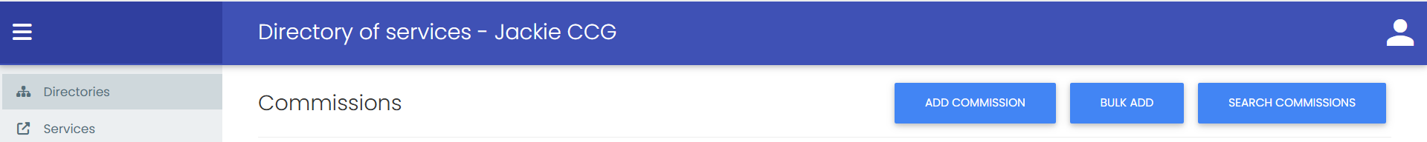

That calls the “Bulk Add” wizard:

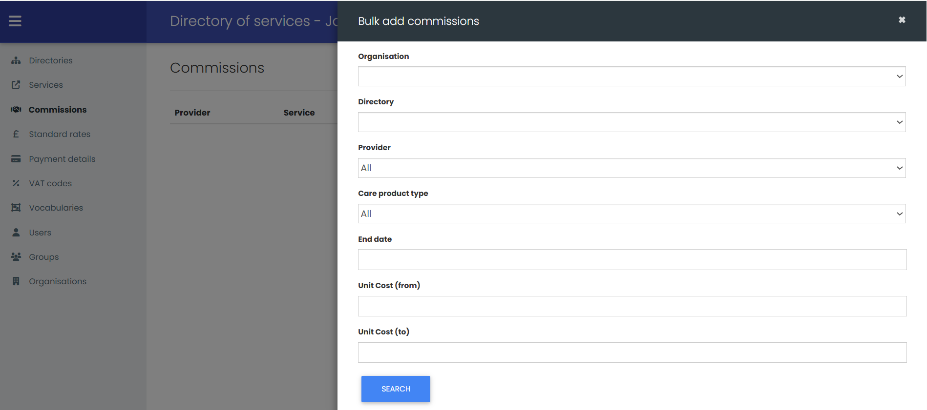

This enables you to Filter for existing Contracted Cost Services using:

- Organisation (ICB)
- Directory
- Provider (you can select an individual Provider if you need to)
- Care Product Type
- End Date (this is mandatory)
- Unit Cost (from)
- Unit Cost (to)
Once the relevant Filters have been applied click “Search”. You will be taken to the next part of the wizard where you will see a list of matching records:
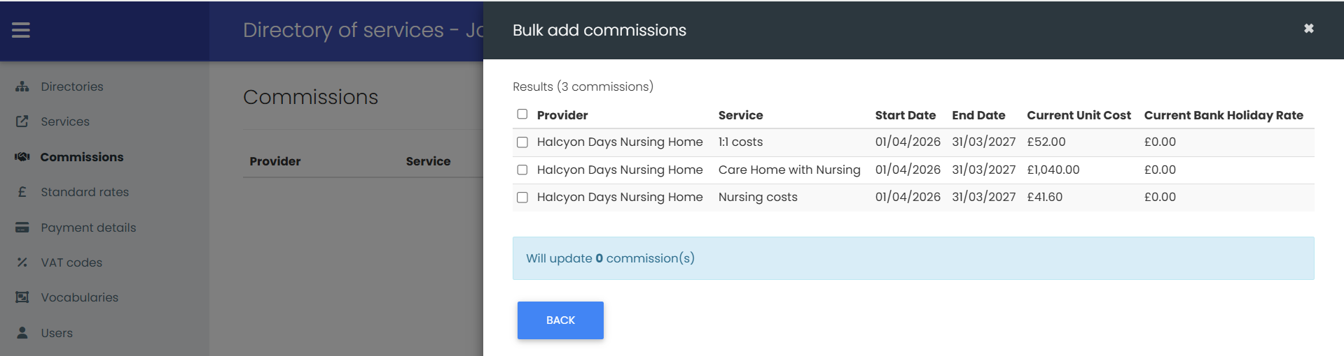

On here you can select the Contracted Cost Services that you wish to apply a price uplift to:
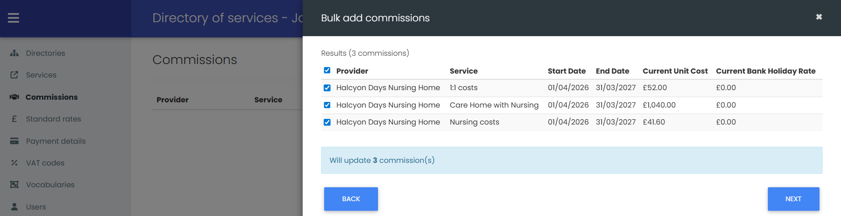
The checkbox before the Provider column enables you to do a bulk select, or you can tick individual Contracted Cost Services.
Once the Contracted Cost Services have been selected click “Next”. You will be taken to the next part of the wizard where you can record either a percentage or a fixed amount increase:
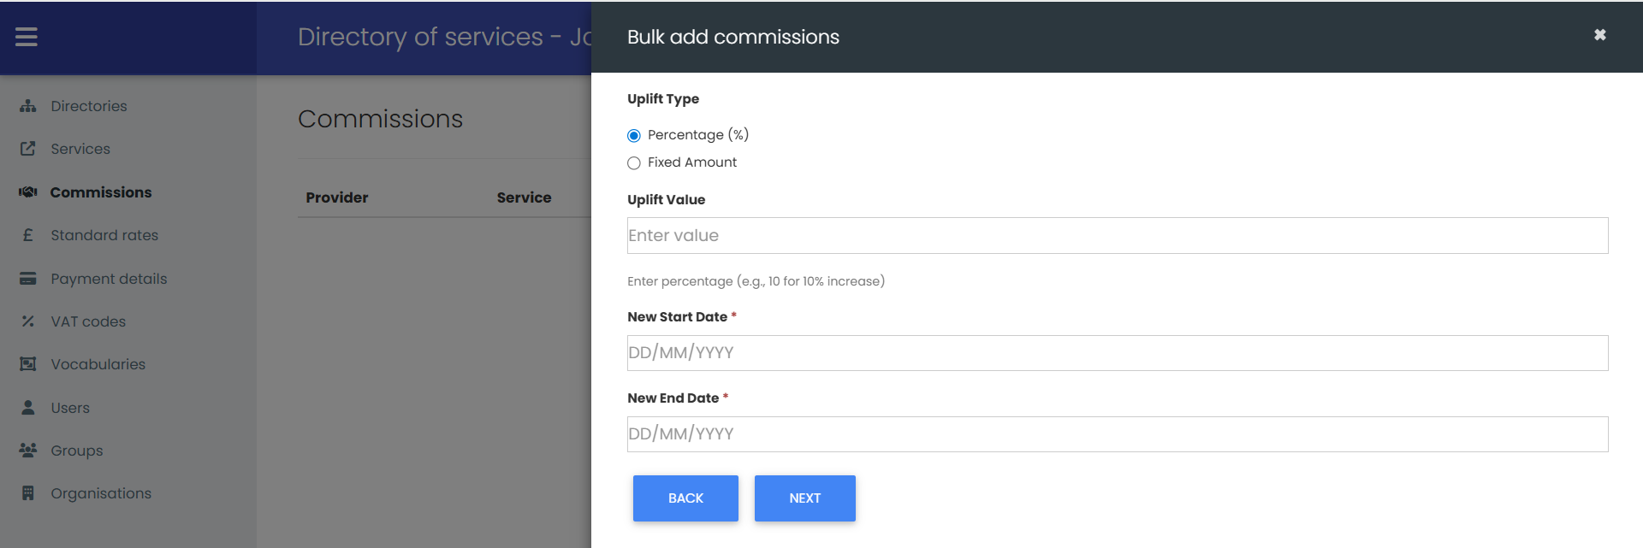
Once you have recorded the Uplift Type, the Uplift Value, the New Start Date and the New End Date click “Next”. You will be taken to the next part of the wizard which a preview of the new Contracted Cost Services:
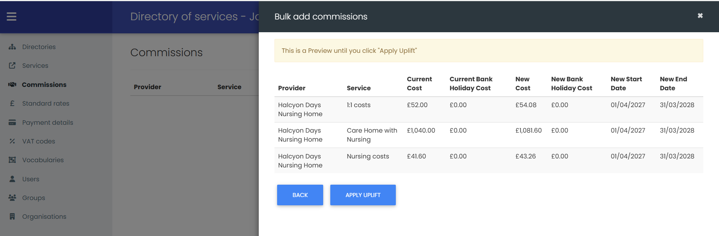
You can use the “Back” button to go back to any of the previous pages of the wizard should you wish to change anything.
Once you are happy with the “Preview” of the new Contracted Cost Services click on the “Apply Uplift” button and the new prices will be added for the services that have been selected.

You can then view the new Contracted Costs by clicking on the “Search Commissions” button:
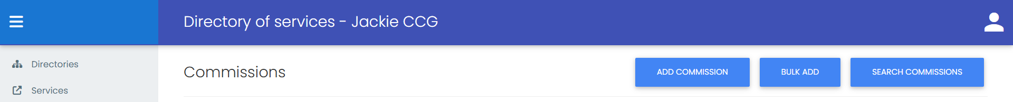
Select Commission Type “Contracted cost”:
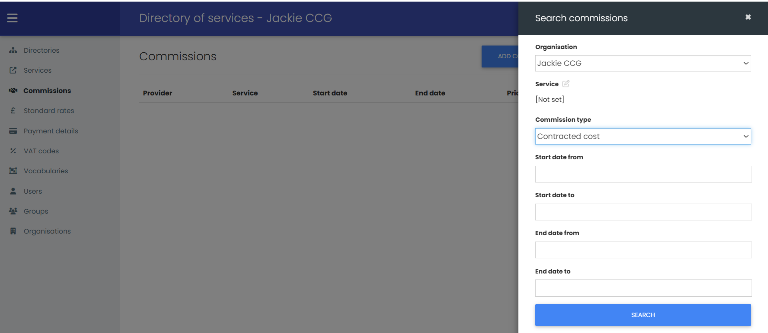
The screen will list matching records:
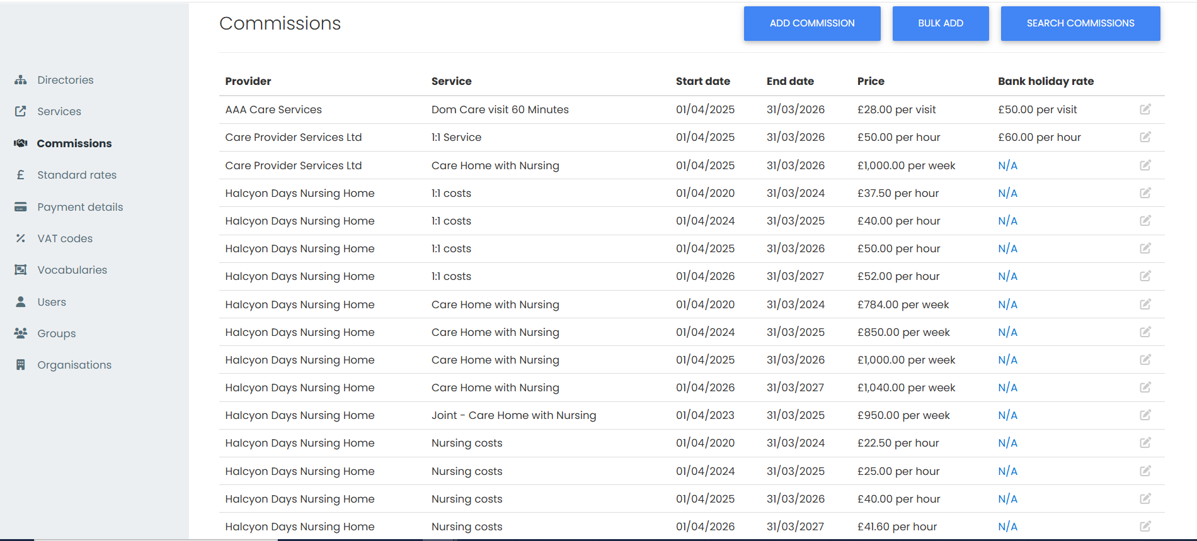

Any care packages that have the uplifted Contracted Costs Services will use the new price from the start date that has been recorded.

- Payment schedules to generate shortfall for backdated Contracted Cost services
Directory of Services - Commissions
Commissioned price service £1,000 per week from 01/04/2023 to 31/03/2024:
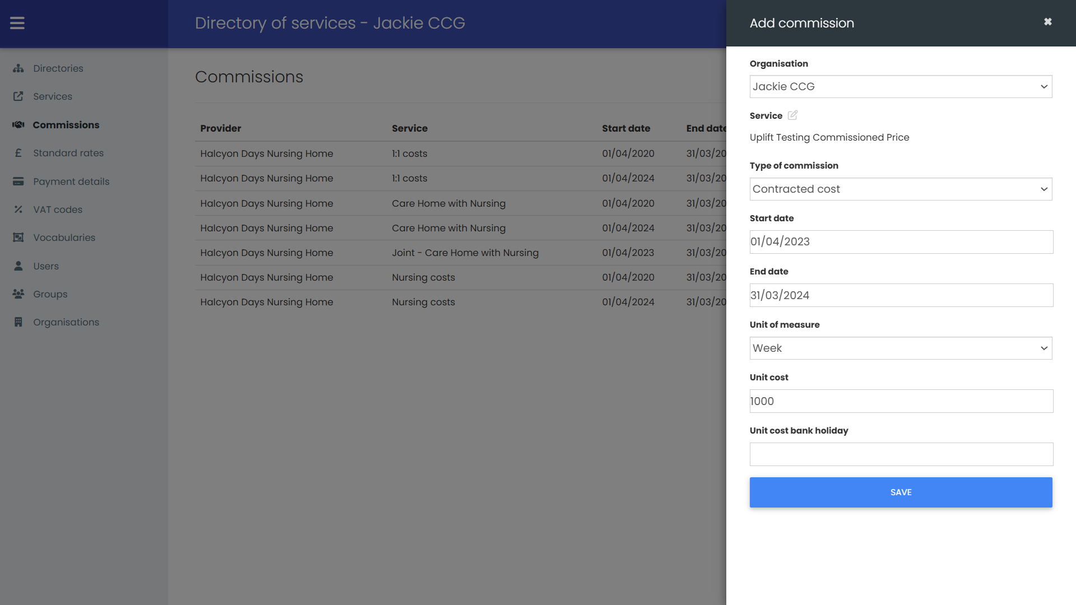
No contracted rate yet for 01/04/2024 to 31/03/2025.
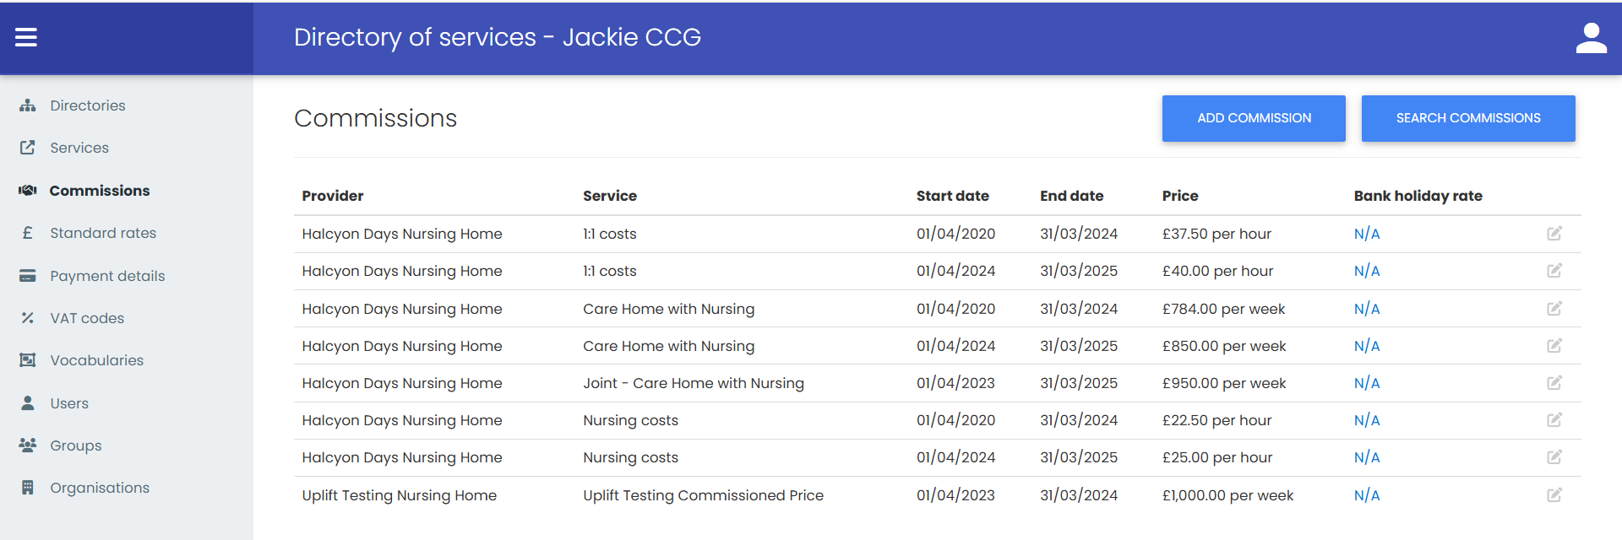

Back-office
New care package added that starts 01/04/2023:
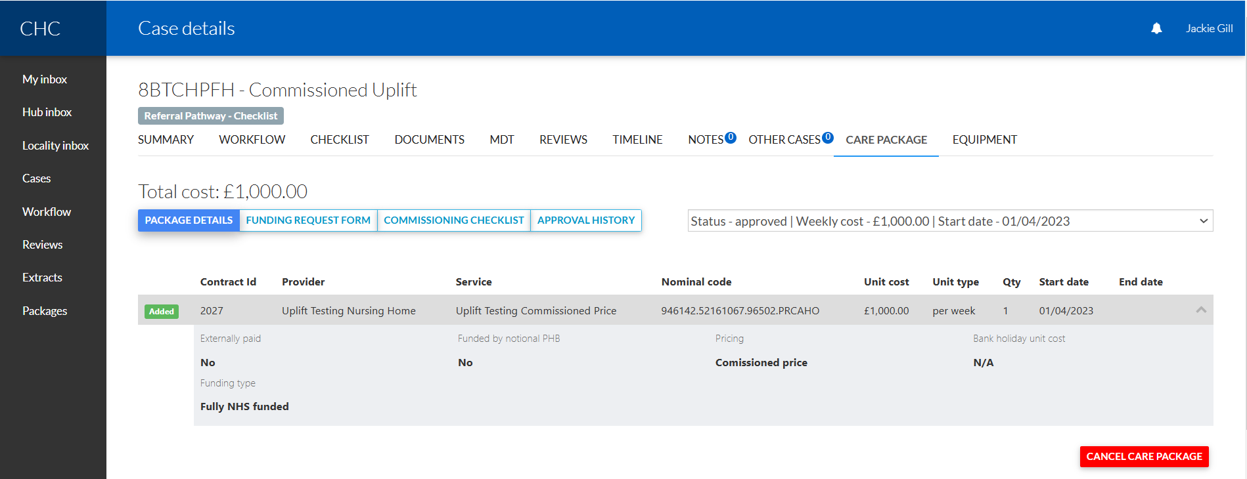
IPA has been accepted in the Provider Portal.
Finance module
Service confirmations have been manually generated:
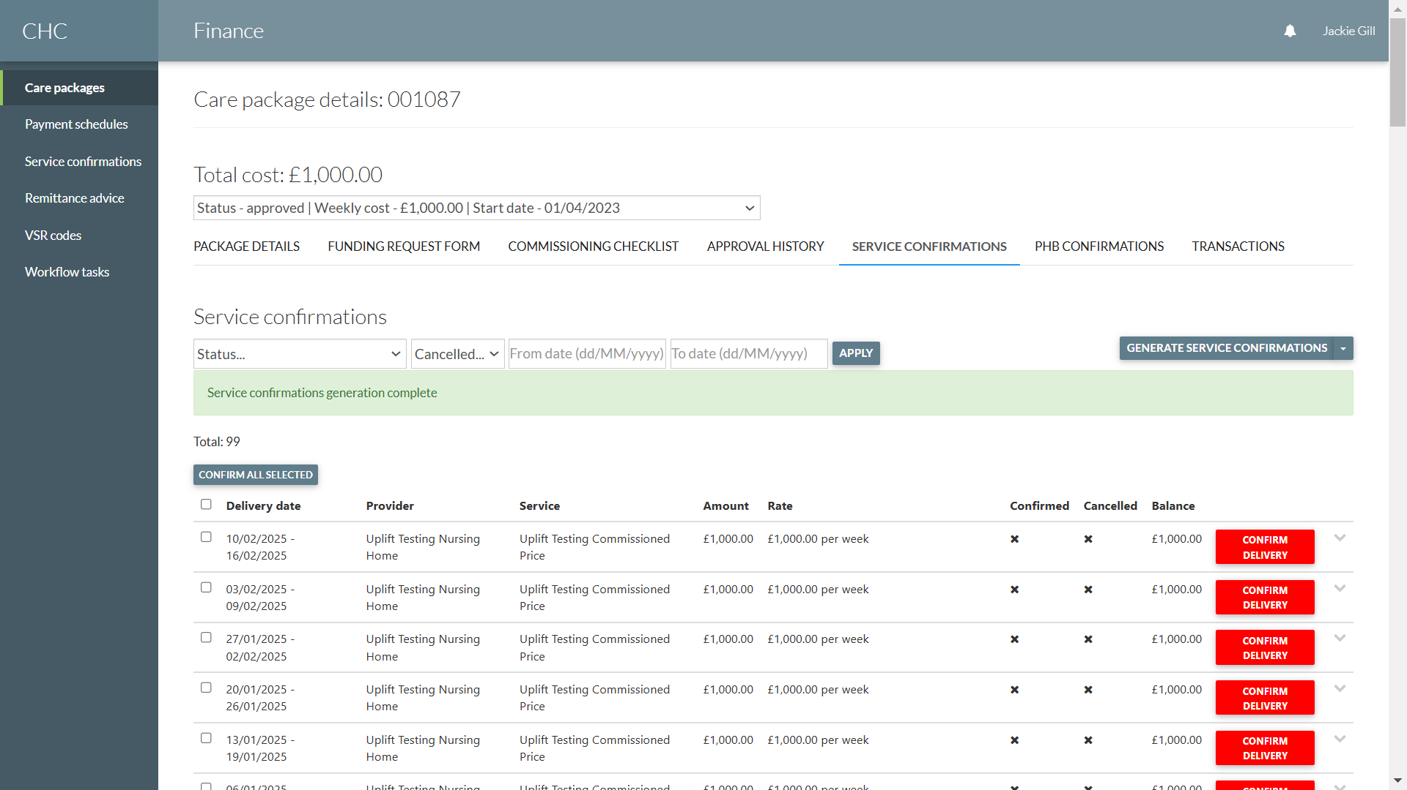
Service confirmations have been generated up to the last week even though there isn’t a contracted price recorded beyond the current contracted price end date of 31/03/2024.
The system will continue to use the last contracted price where one doesn’t exist (this is different from standard rates where there has to be a standard rate for the date range).

The service confirmations have now been confirmed as delivered:
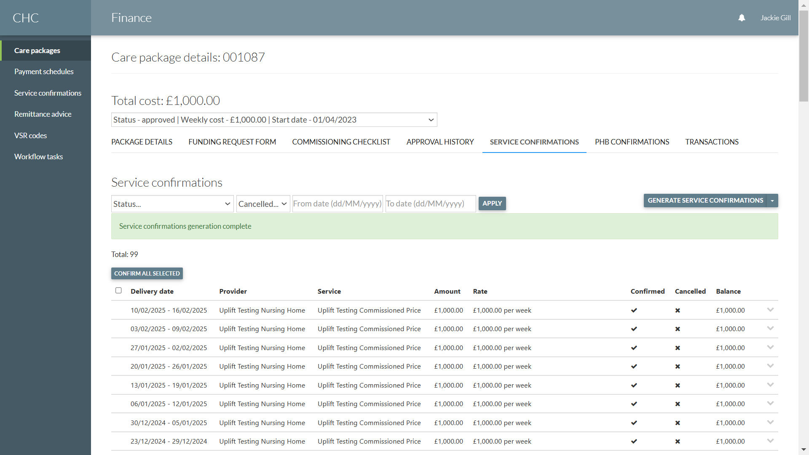

Finance – Finalize Payment Schedule
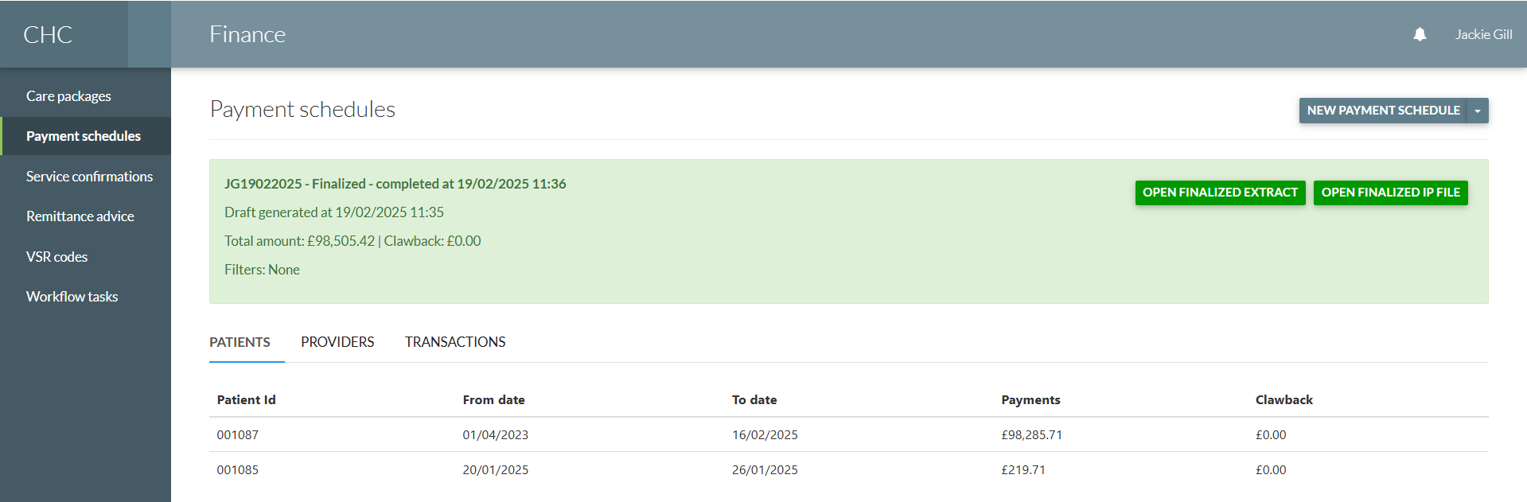
That generates the payments to the Provider(s).

Directory of Services – add new Commissioned Price (backdated start date)
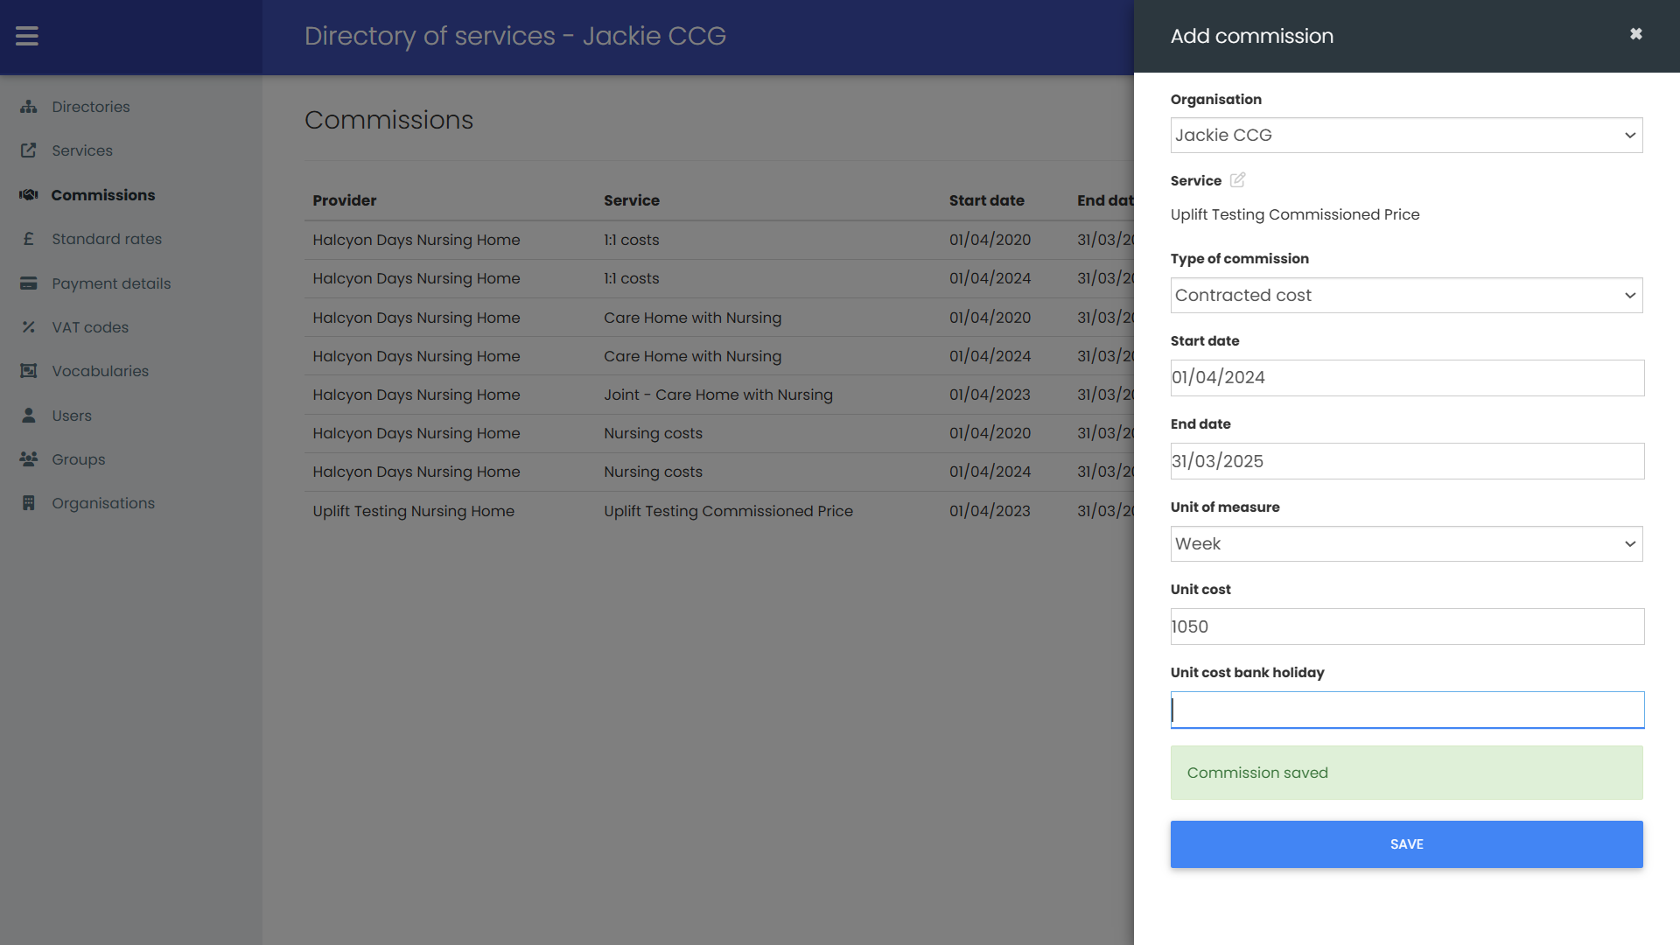
Start date is 01/04/2024. Packages have been paid on the previous contracted rate £1000 per week.
Once the new contracted rate has been saved:
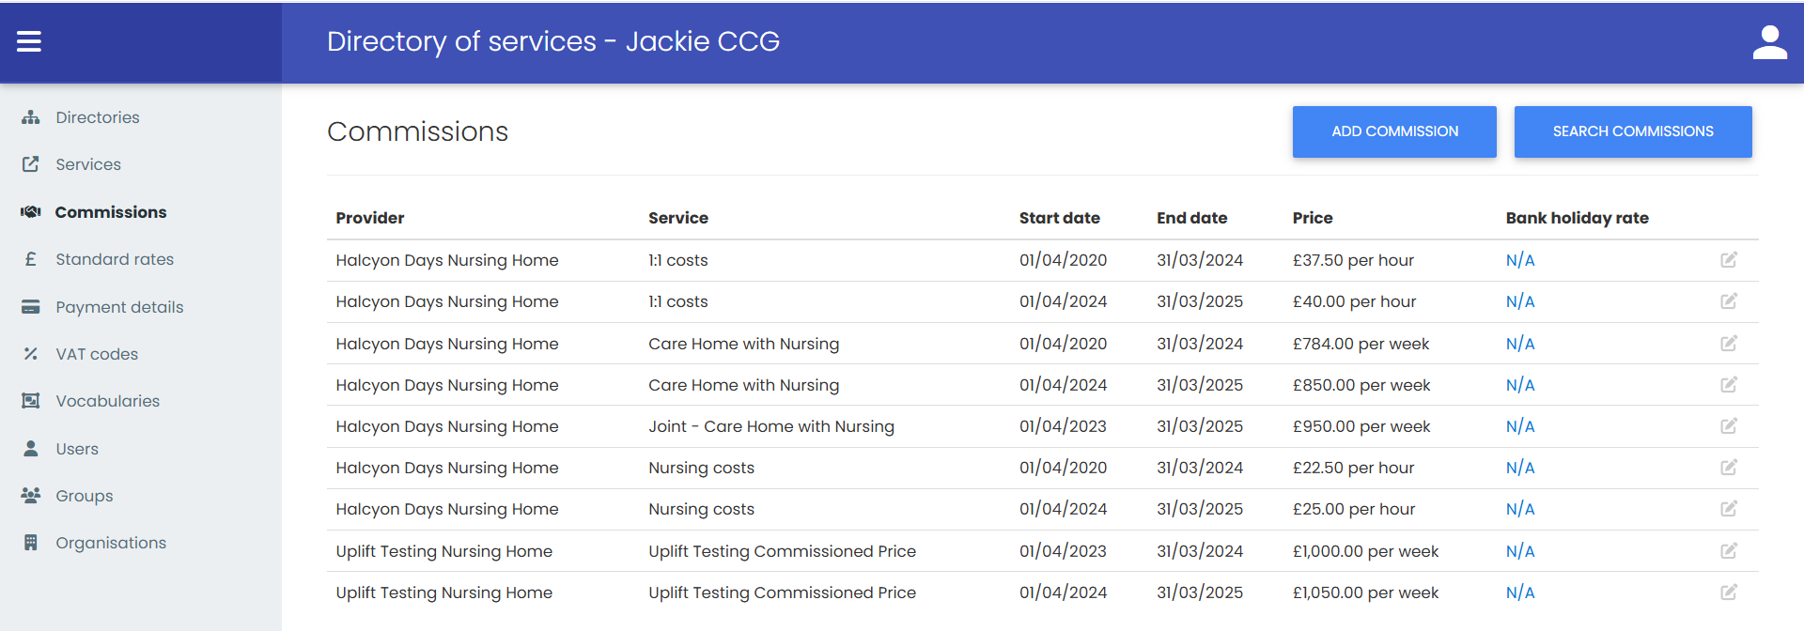

Finance – Payment Schedules
Click on the drop-down alongside New Payment Schedule:
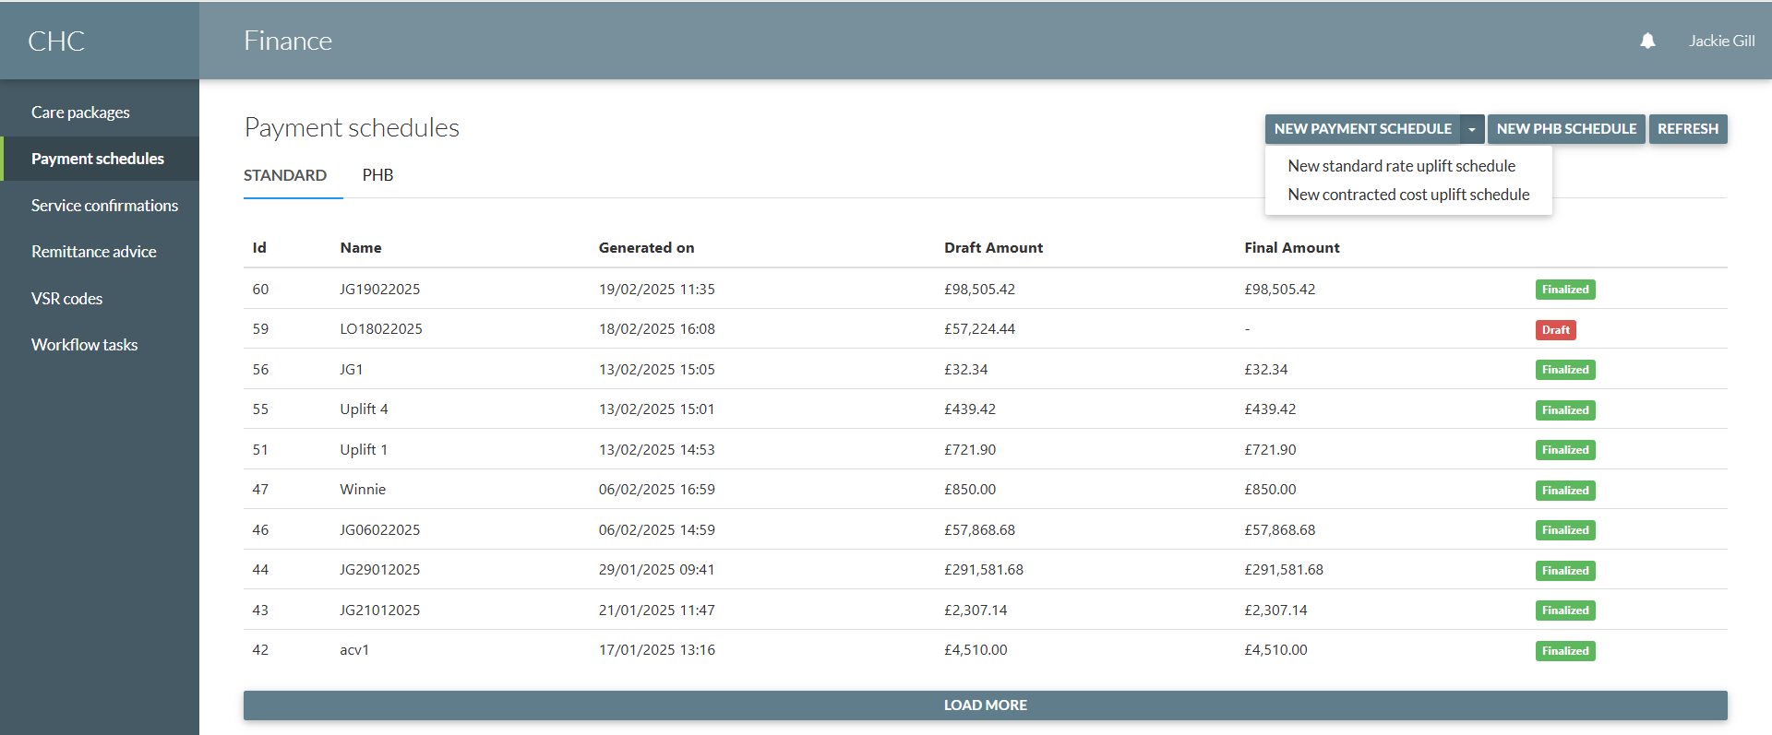
Click “New contracted cost uplift schedule”:
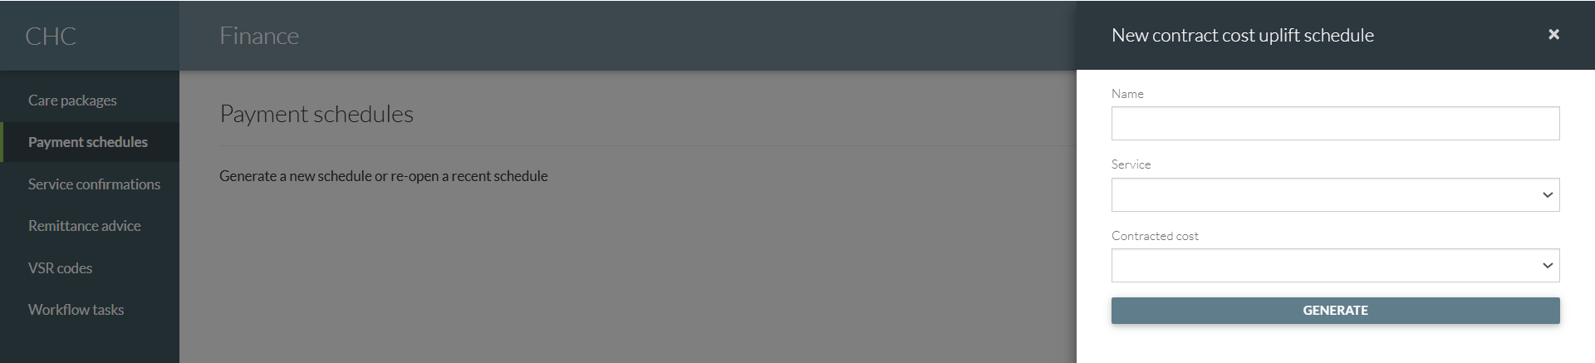
Type in a name, select the Provider/service:
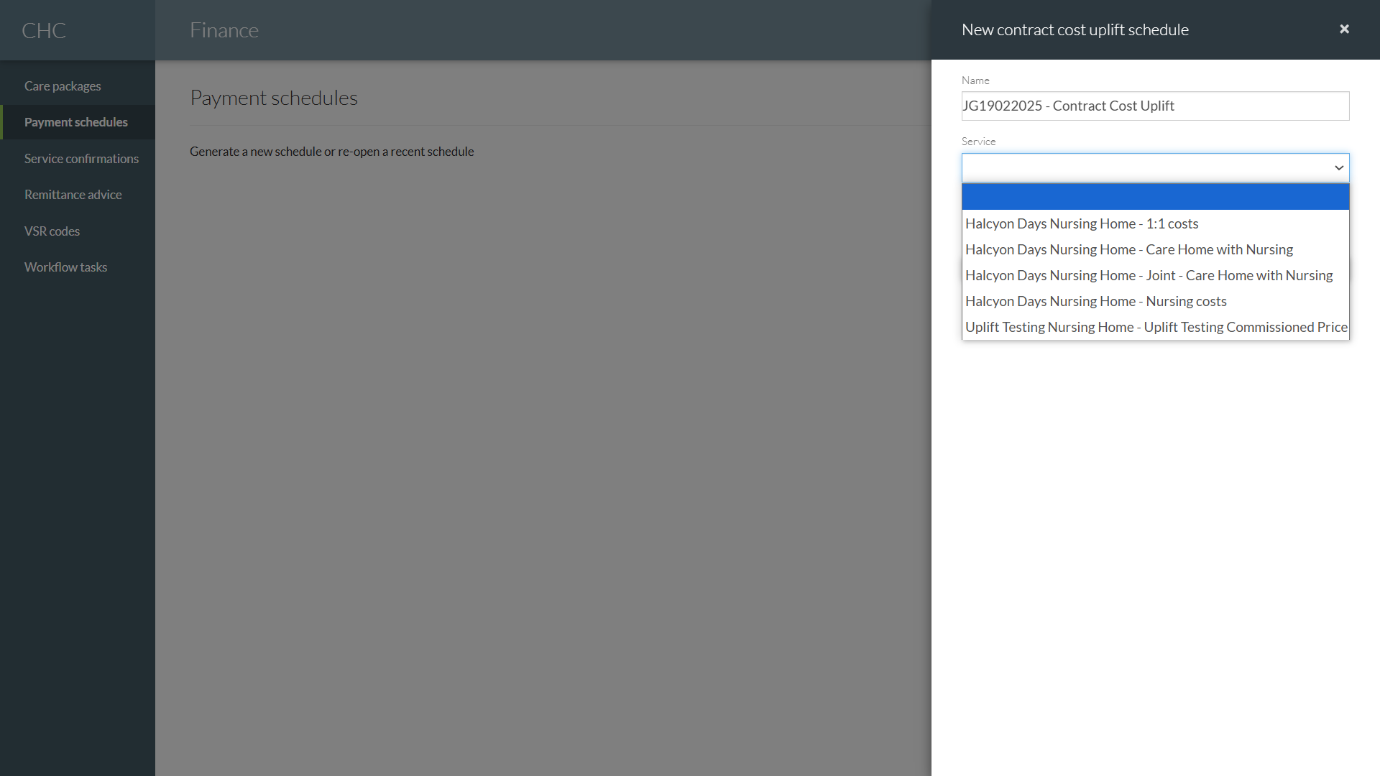
The system will only list Provers/Services that have contracted prices. It will not list any Standard Rate services.
Then select the contracted cost that you want to use for the Contract Cost Uplift:
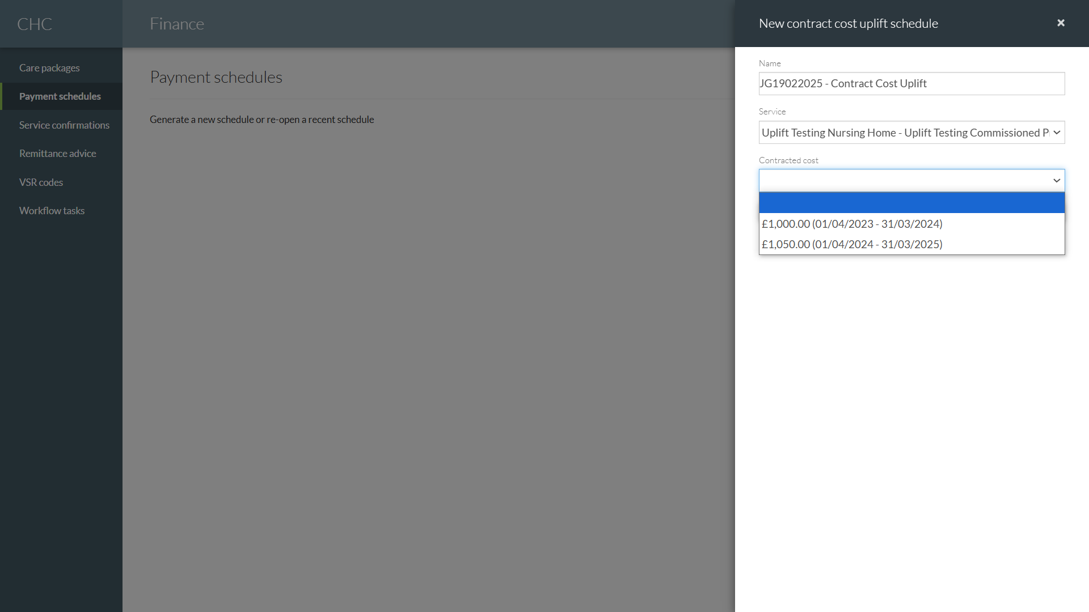
Click on the generate button:
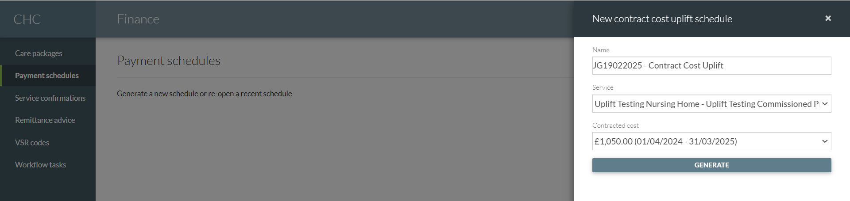
Once generated you can check the Contract Cost Uplift details:
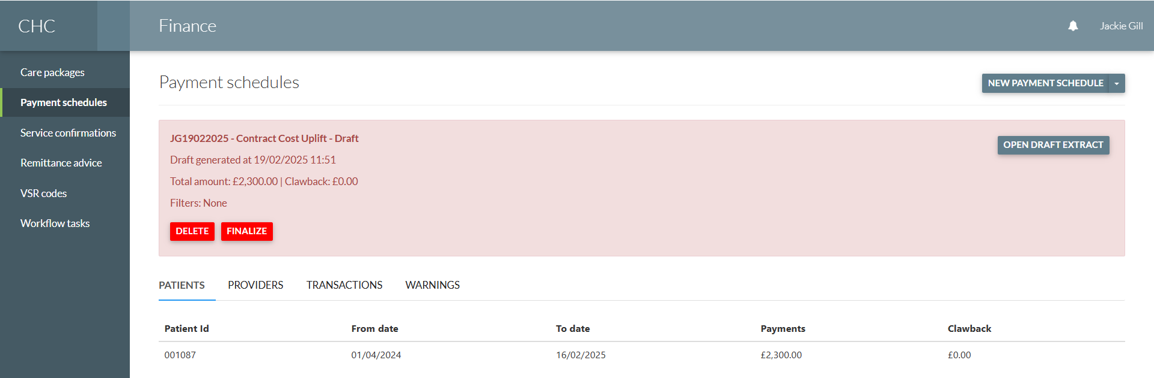

The transactions tab will list the price uplift amounts for each day or week (based on service unit of measure):
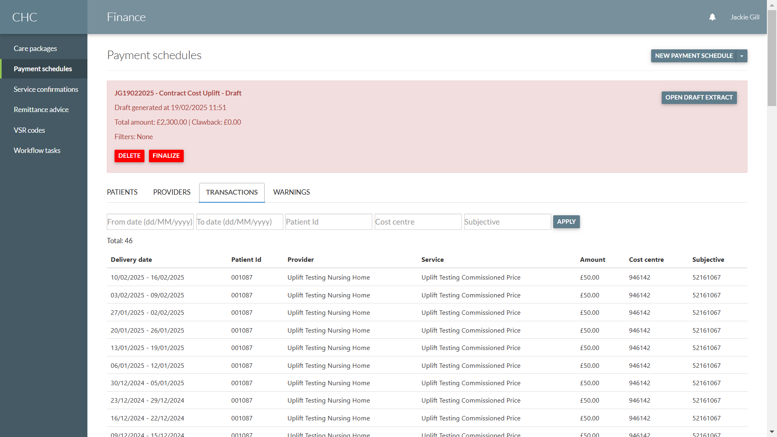
Click on the “Open Draft Extract” button to view the transactions in Excel.
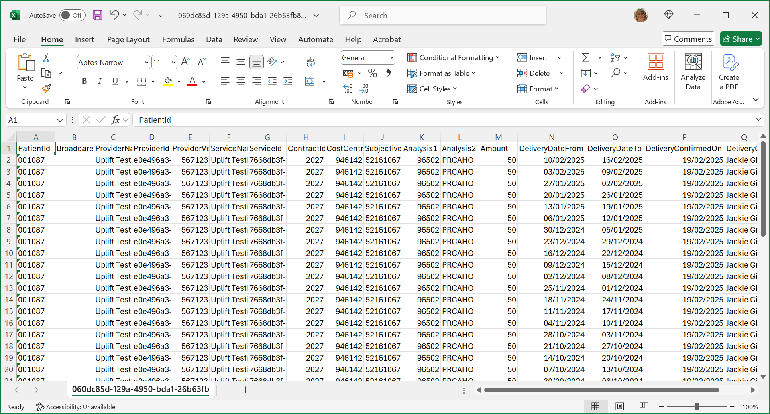

Once you are happy with the Draft Contract Cost Uplift Payment Schedule it can be Finalized:
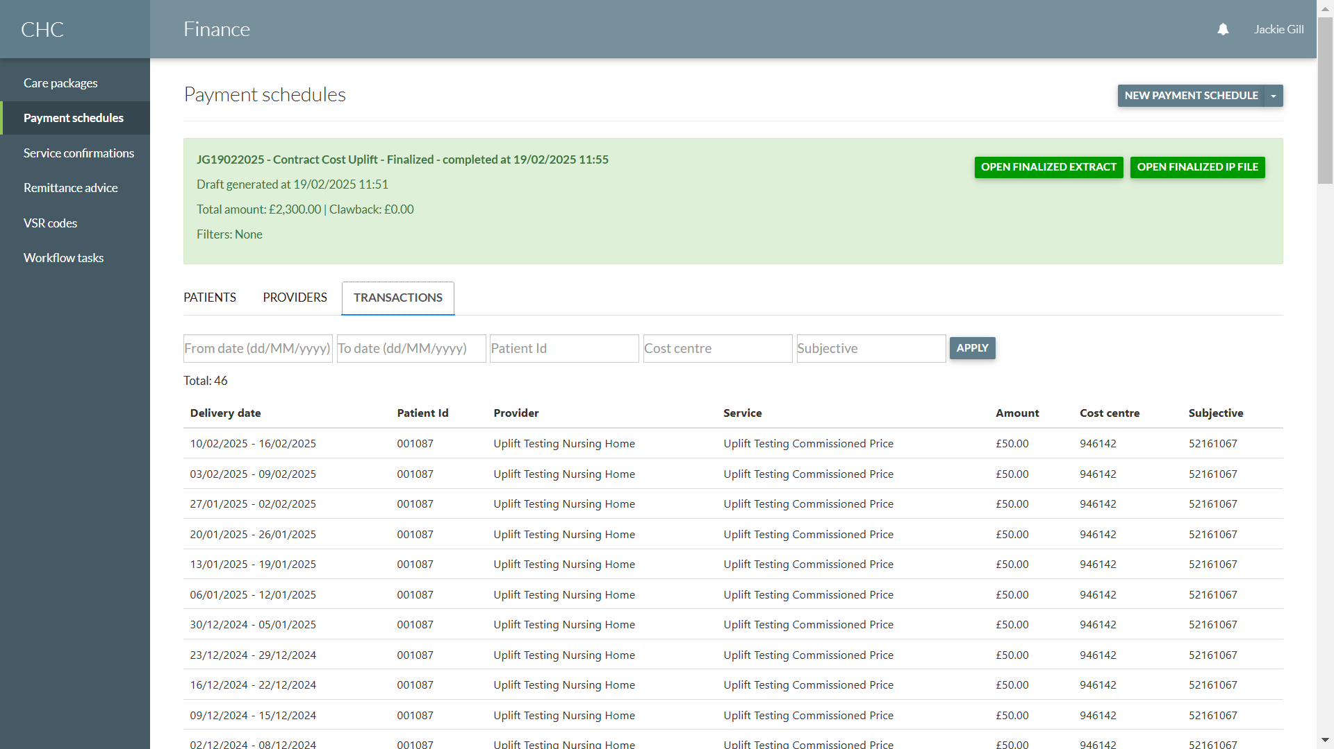
The IP File is then available to be uploaded to SBS Wakefield to pay the shortfall in the uplifted amounts e.g. £50 per week.
Care Package – Service Confirmations tab
The amount will be updated to include the uplifted amount e.g. £1050.
When you expand on the service confirmation you will see two payment transactions; one for the original contracted cost and one for the Contracted Cost Uplift amount:
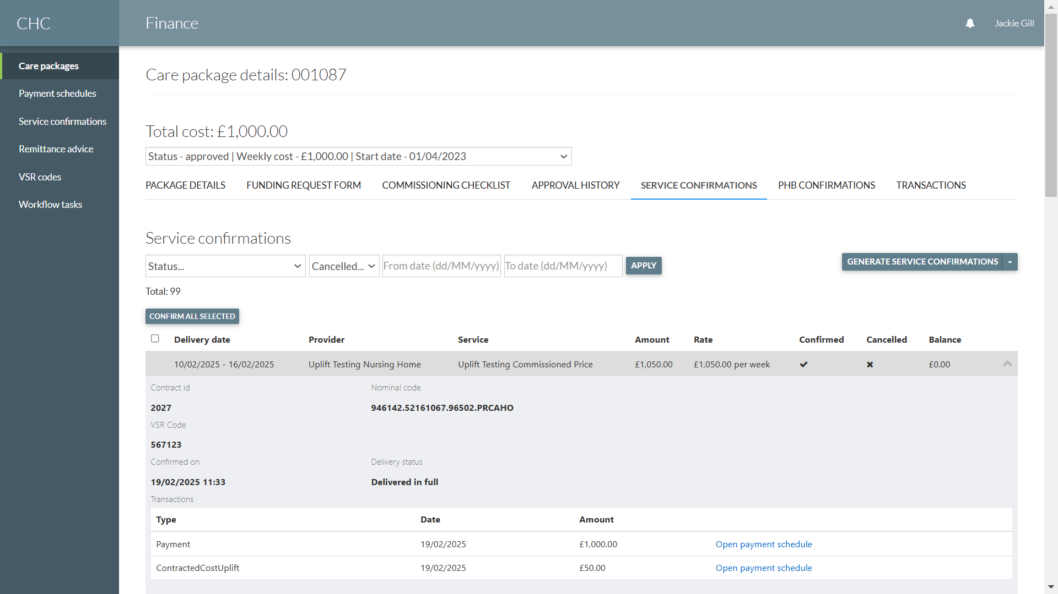

- Apply Manual Uplift to Services with Ad-hoc Price
Back-office – Packages screen:
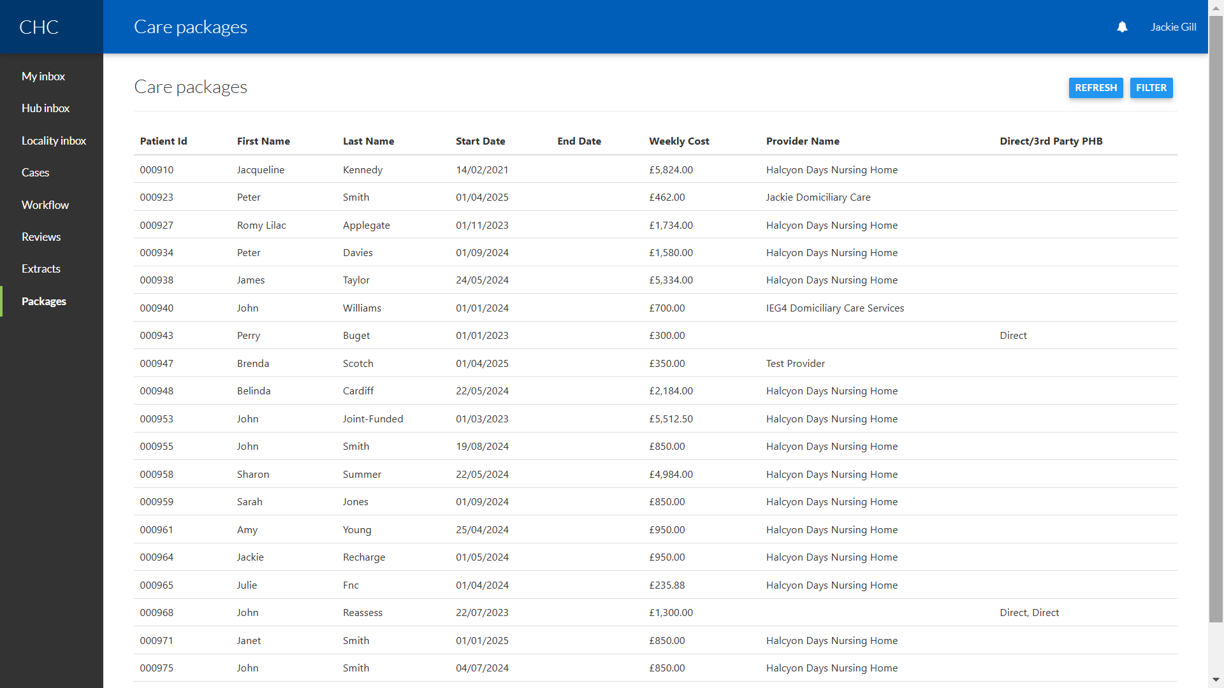
Click on the Filter button:
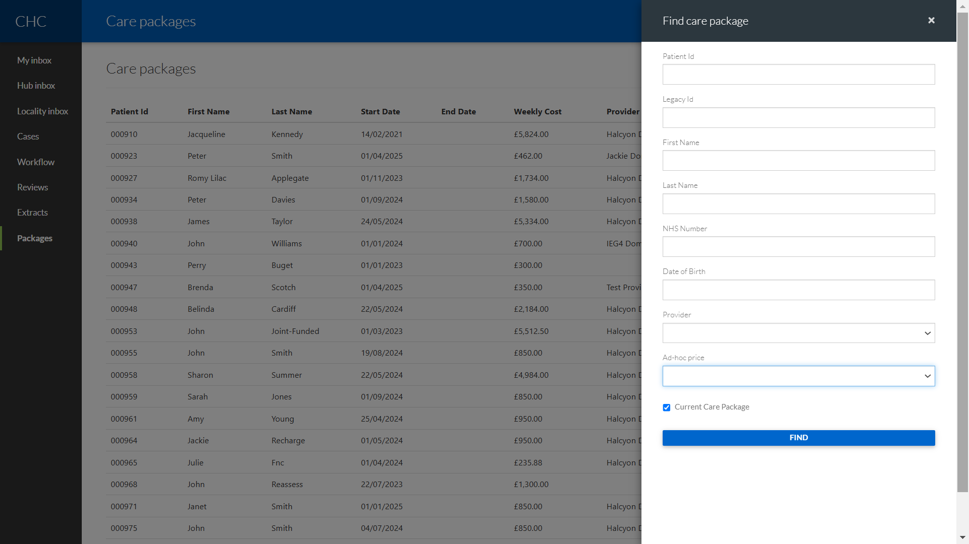

Click on Ad-hoc price drop-down:
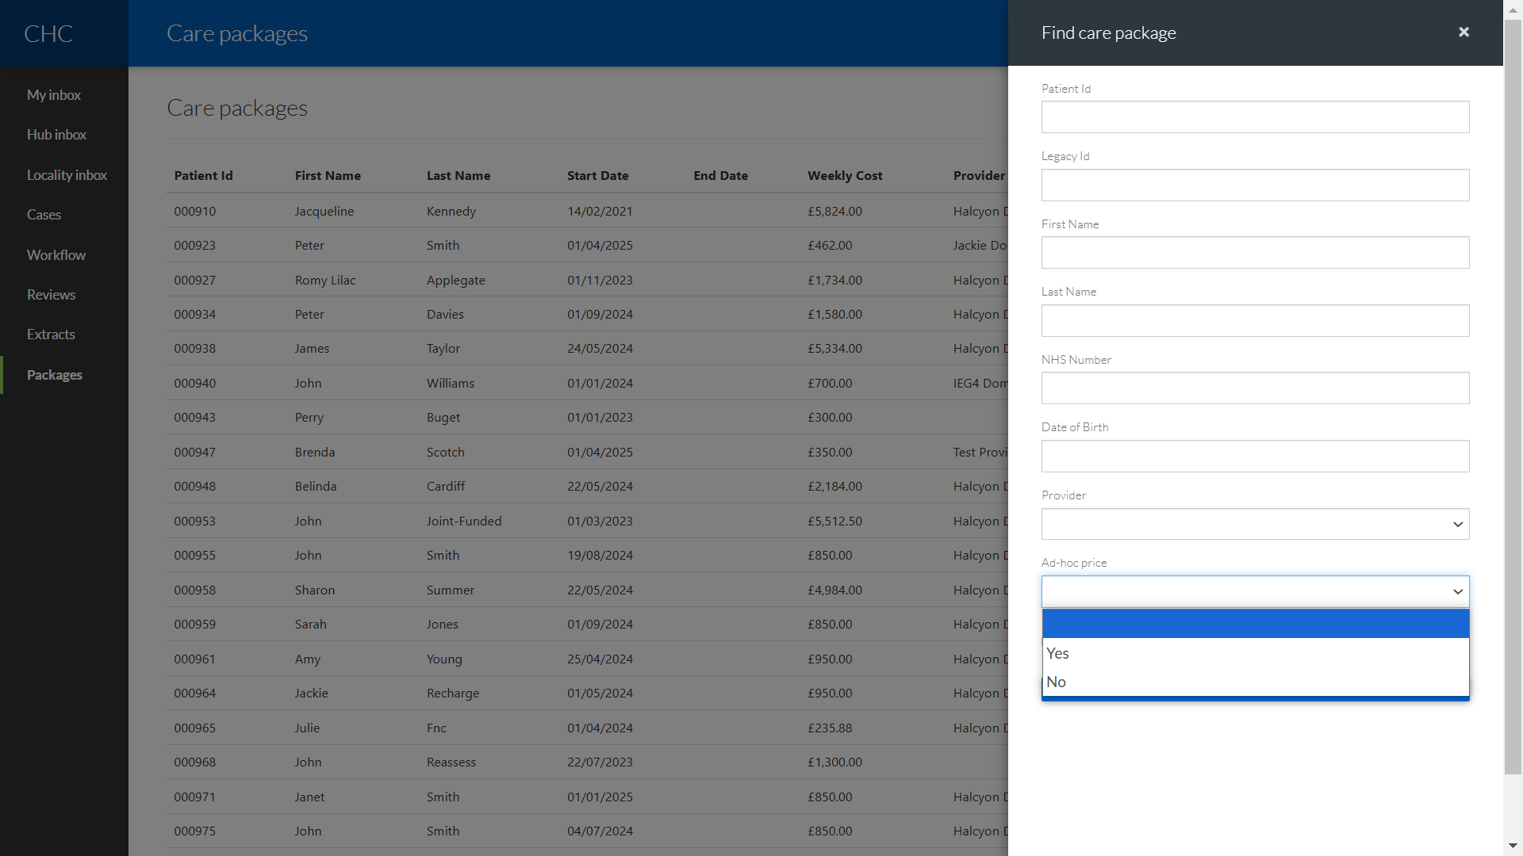
Select Yes you will then see another drop-down for Ad-hoc uplift status:
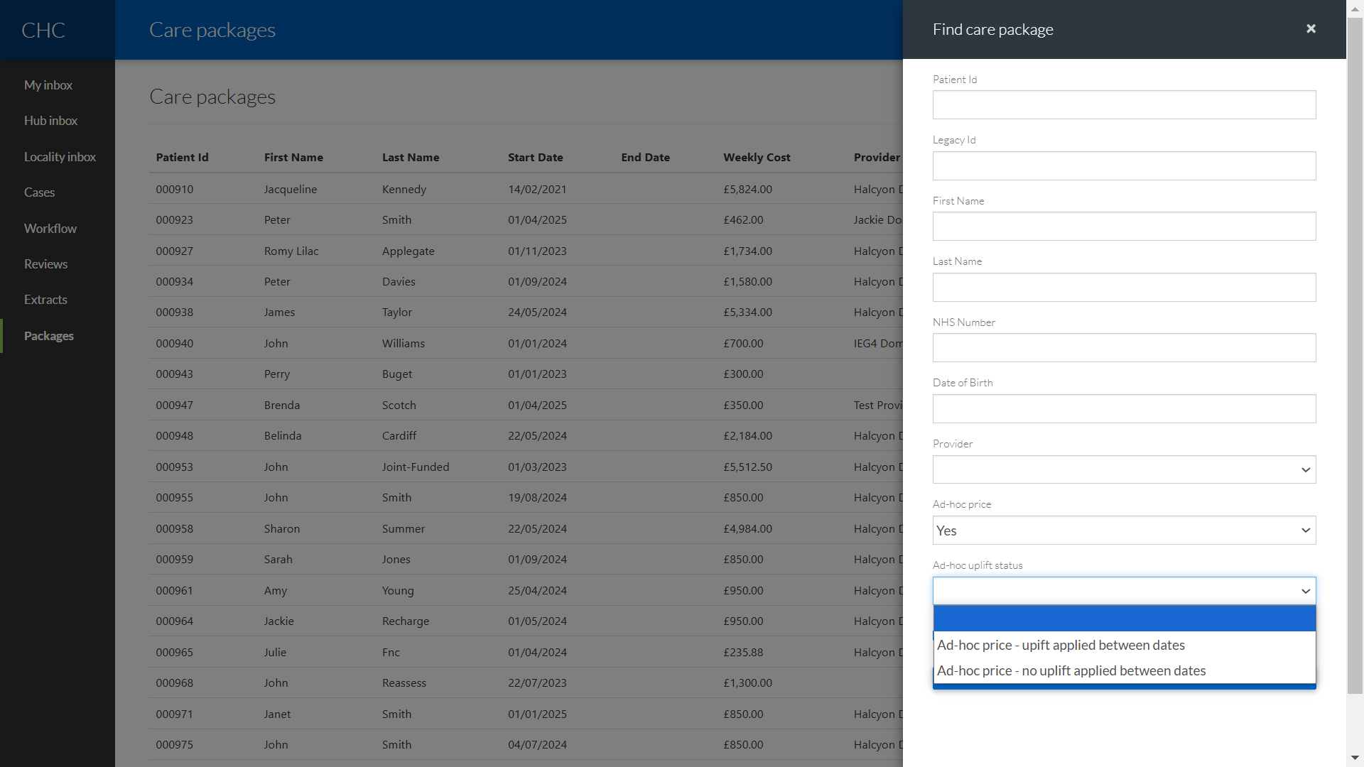
You can then select to filter for care packages that either have or haven’t had an uplift between dates.

You will then be presented with fields for the date range. The system will default in the next financial year, but you can change the date range if required:
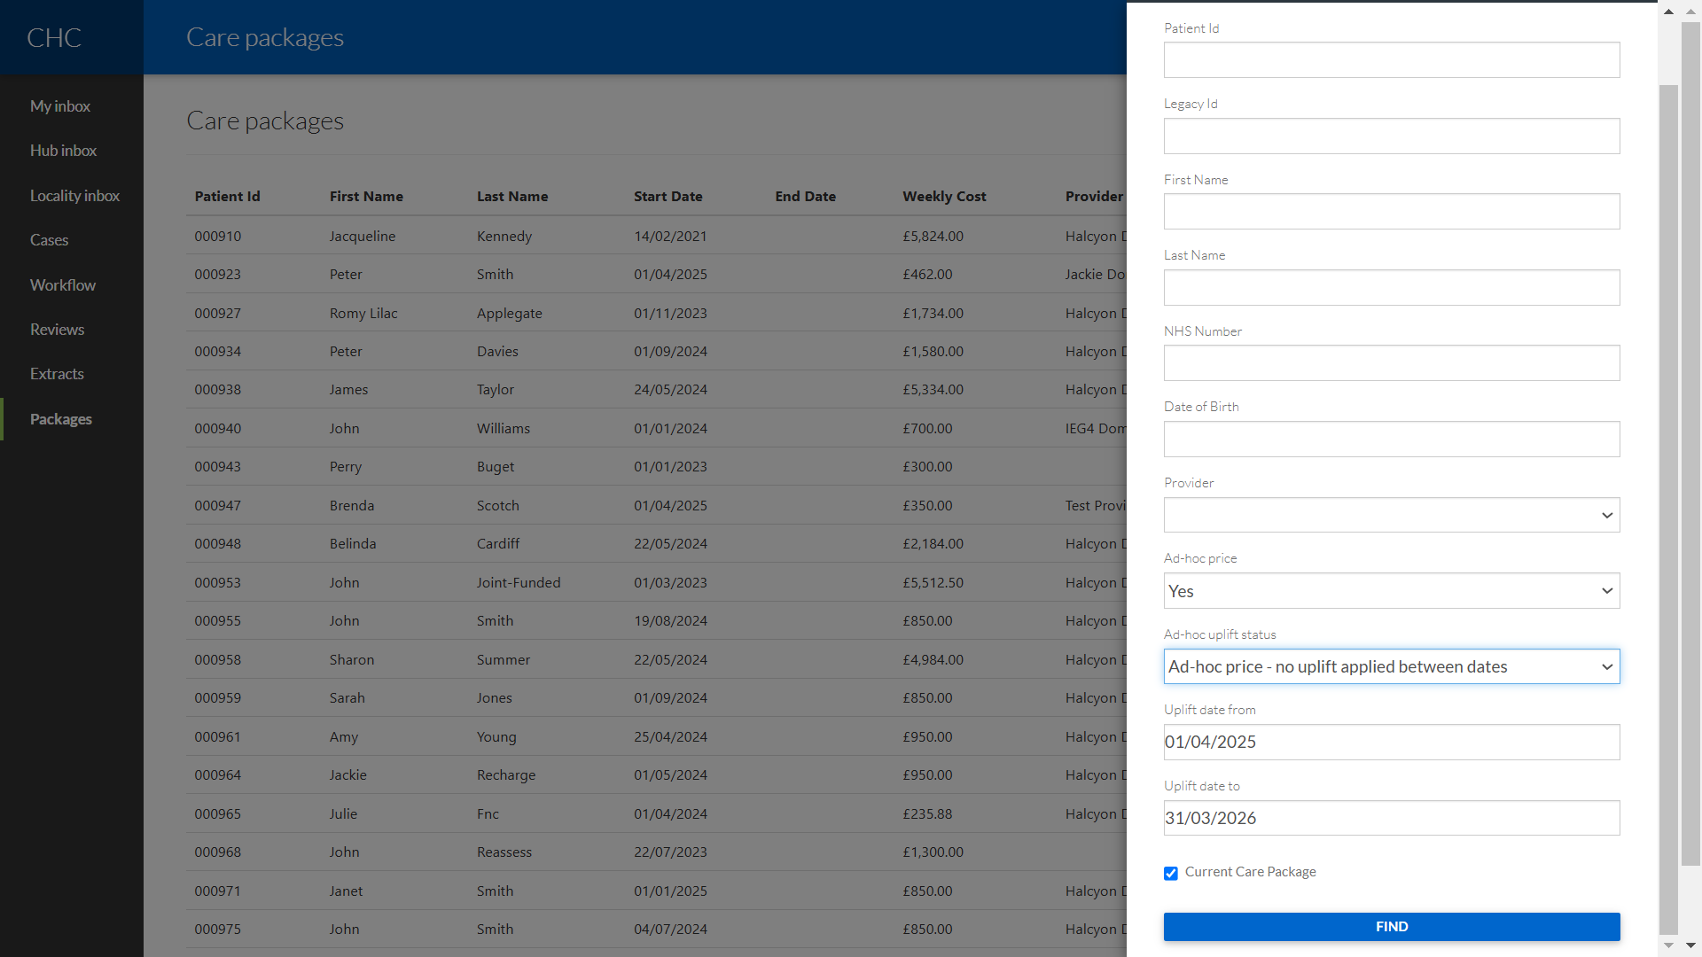
The system will then list care packages that meet your Filter criteria:
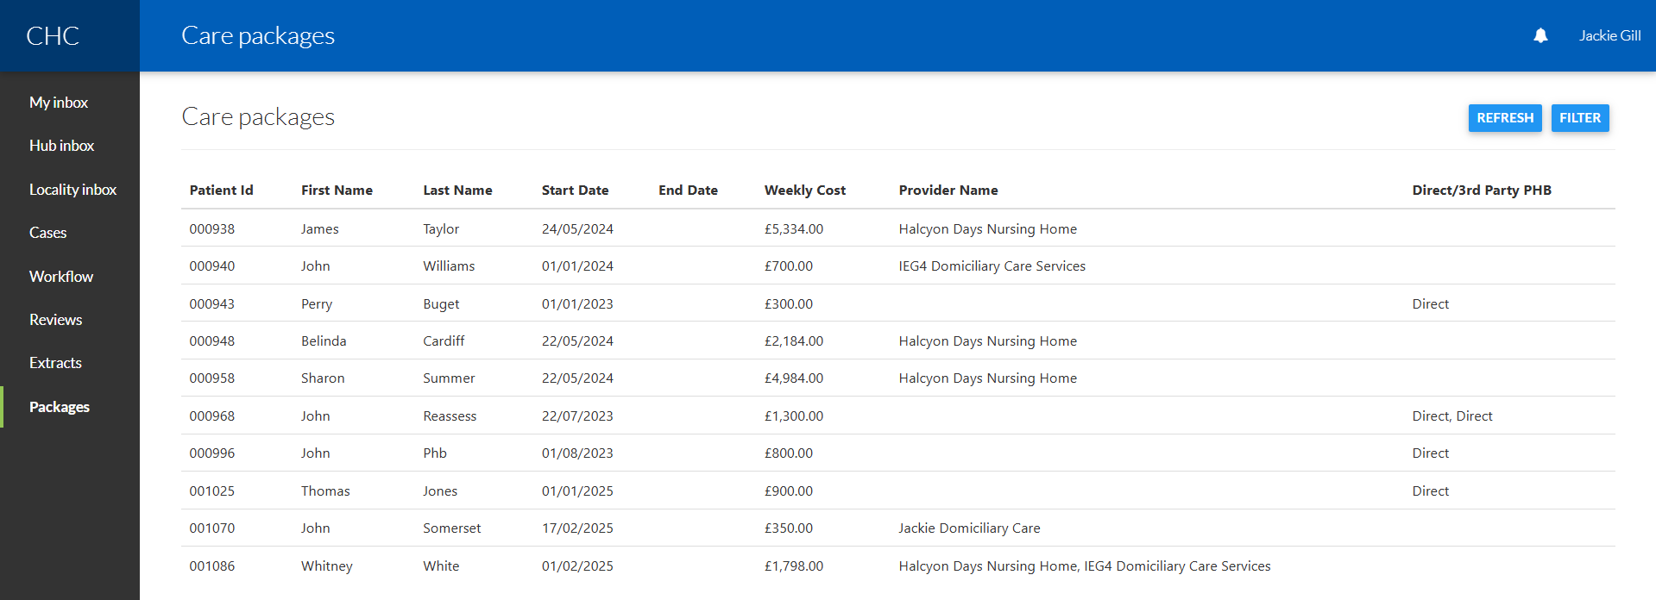

Please note that currently the search results are including Direct and Third Party PHB care packages.

To uplift an ad-hoc price click on the care package:
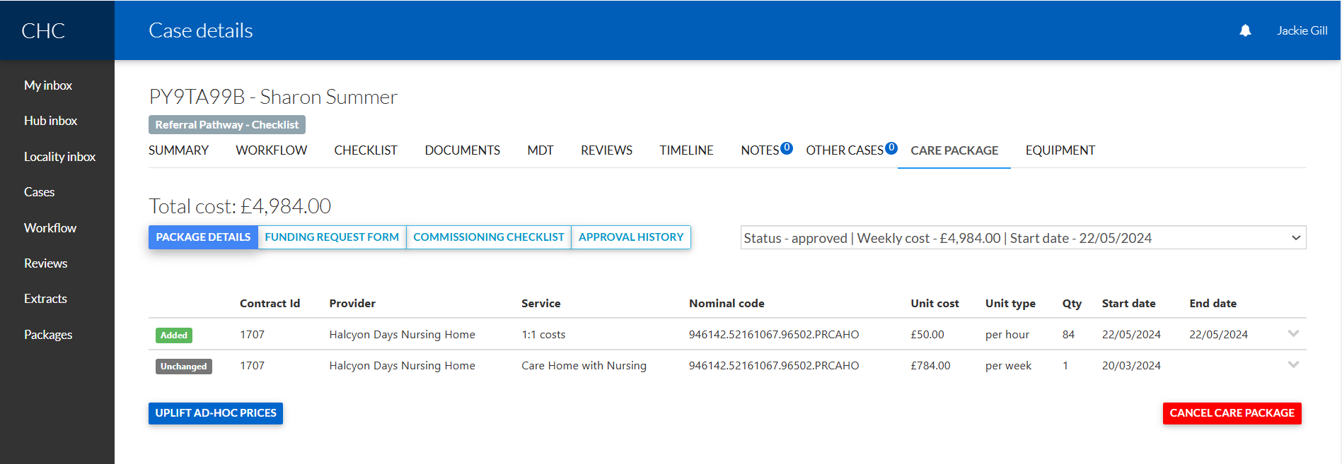
In the above example this care package has one service that has a commissioned price “Care Home with Nursing” and one service that has an ad-hoc price “1:1 costs”.
Click on the “Uplift Ad-hoc Prices” button and you will see the ad-hoc service(s) listed:
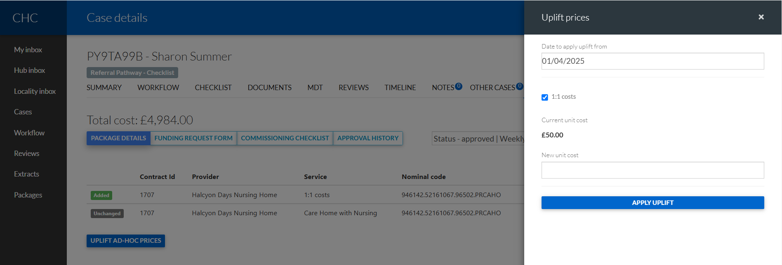
Type in the Date to apply the uplift from and the new unit cost and click on the “Apply Uplift” button.
You will get warnings if the ad-hoc price uplift is not logical e.g. if you are trying to apply an uplift that is after the service end date:
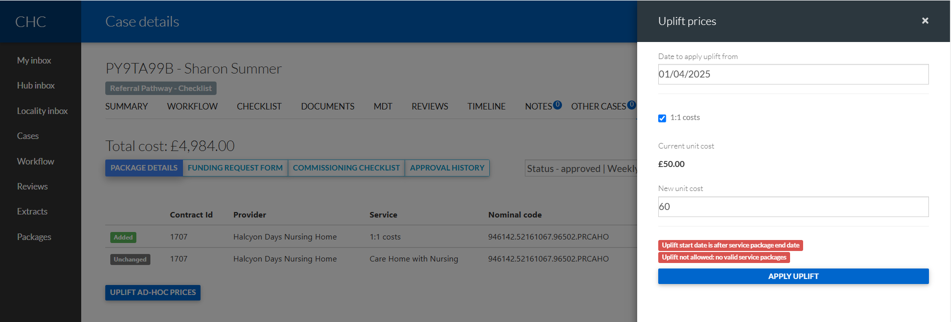

Otherwise the system will allow you to apply the ad-hoc price uplift:
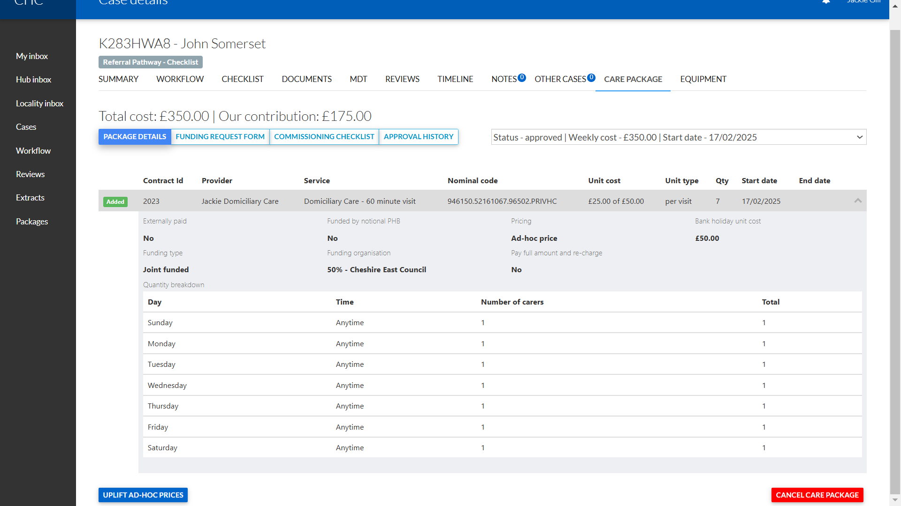
The above package has an ad-hoc price for the Domiciliary Care service – 60 minute visit. The rate is currently £50 per visit. That service is also Joint Funded with the Local Authority using a 50% split.
We will now uplift that price to be £60 per visit from 01/04/2025:
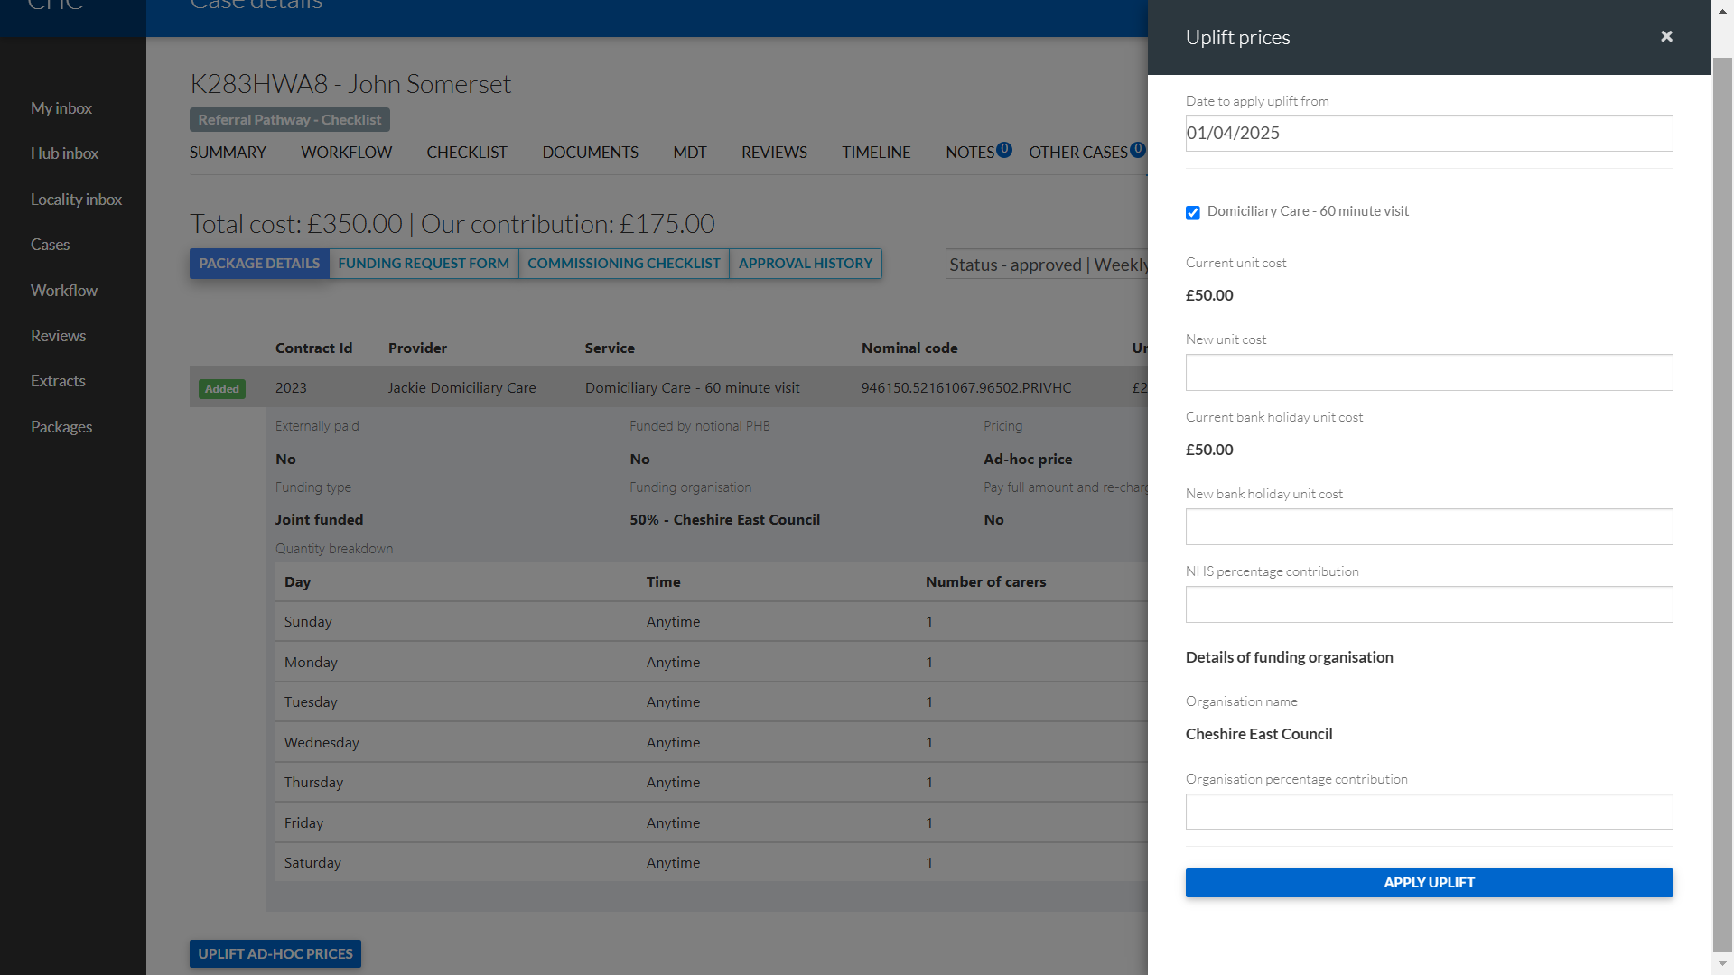

Complete the fields:
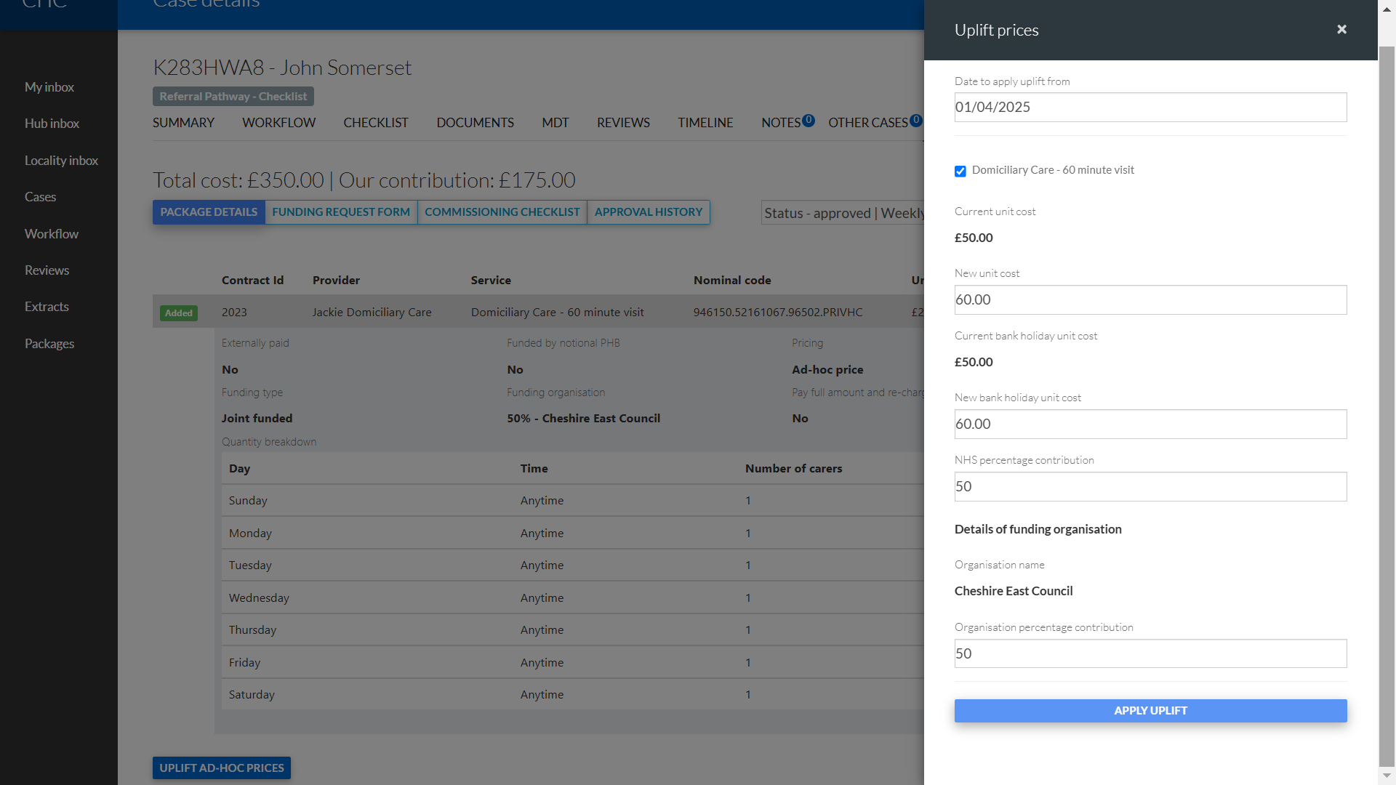
Click on the Apply Uplift button:
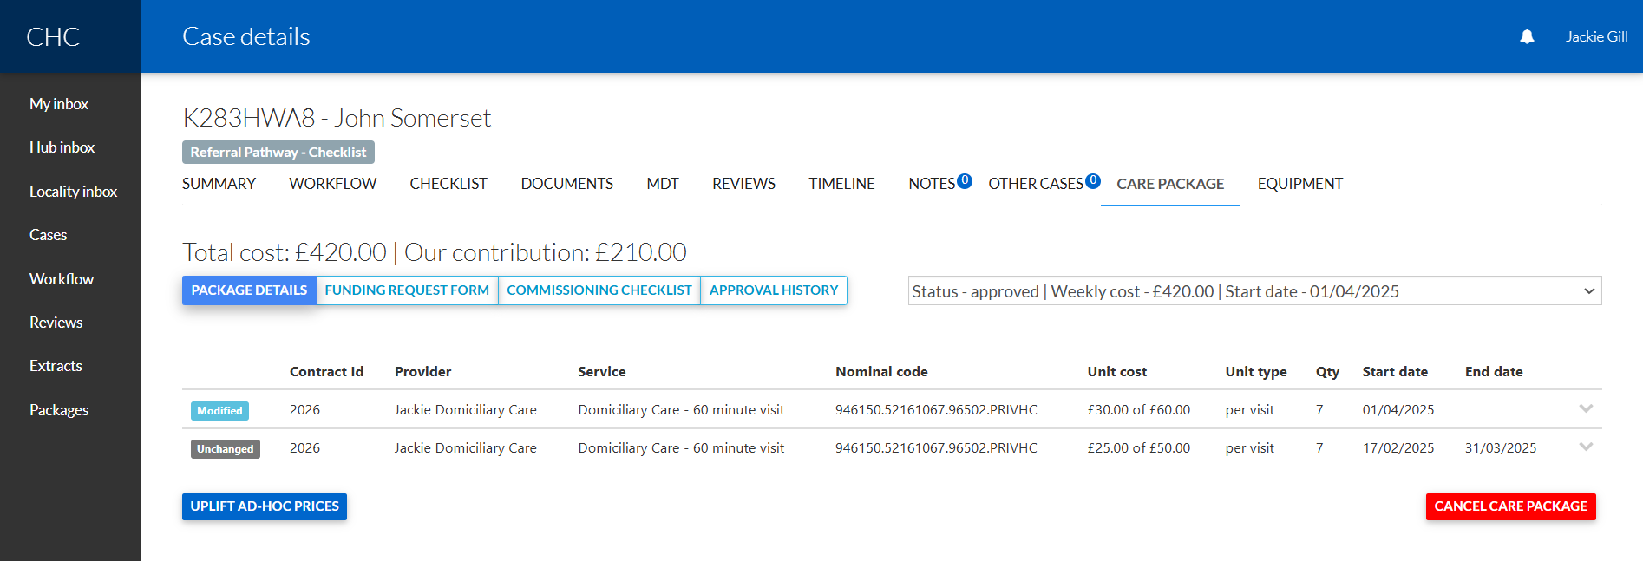
The system is now displaying the new rate for the ad-hoc service with the start date 01/04/2025 and it has put an end date against the existing rate of 31/03/2025.

The Bank Holiday Rate has also been updated:
