Client Groups – Release Notes
Client Groups are now configurable for each ICB.
- Settings
In Settings there is a new List for ICBs to set up their required Client Groups.
That new List already has the built-in system-defined Client Groups (for re-using the existing hard-coded options that we already had so that existing records will have the existing data) as those options are used to control whether Primary Diagnosis is captured or not (in the Care Package Approval Workflows).
  - PD
  - MH with Dementia
  - MH not Dementia
  - LD
New List in Settings – Client Groups
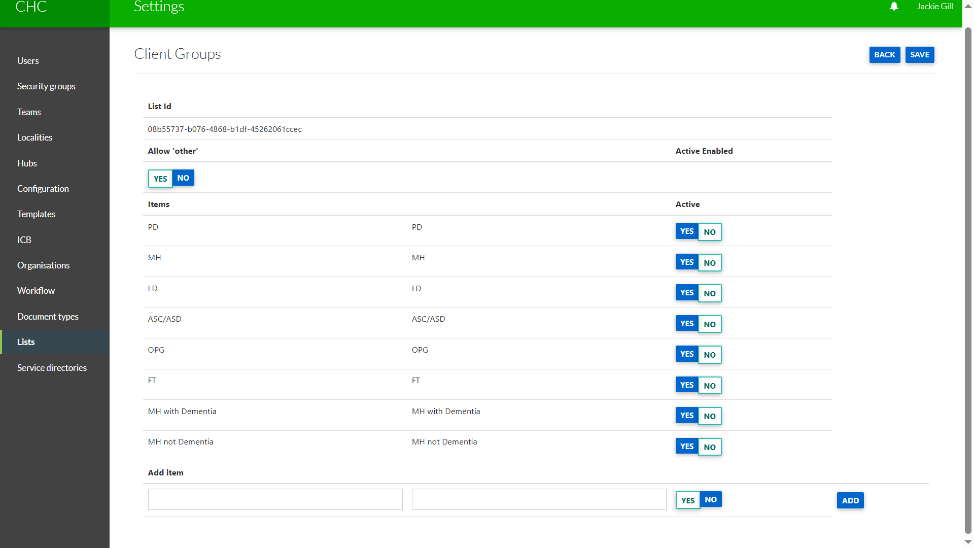

There is the ability for the ICB to select in Settings whether you want to use the in-built system-defined Client Groups.

Setting Active as Yes or No:

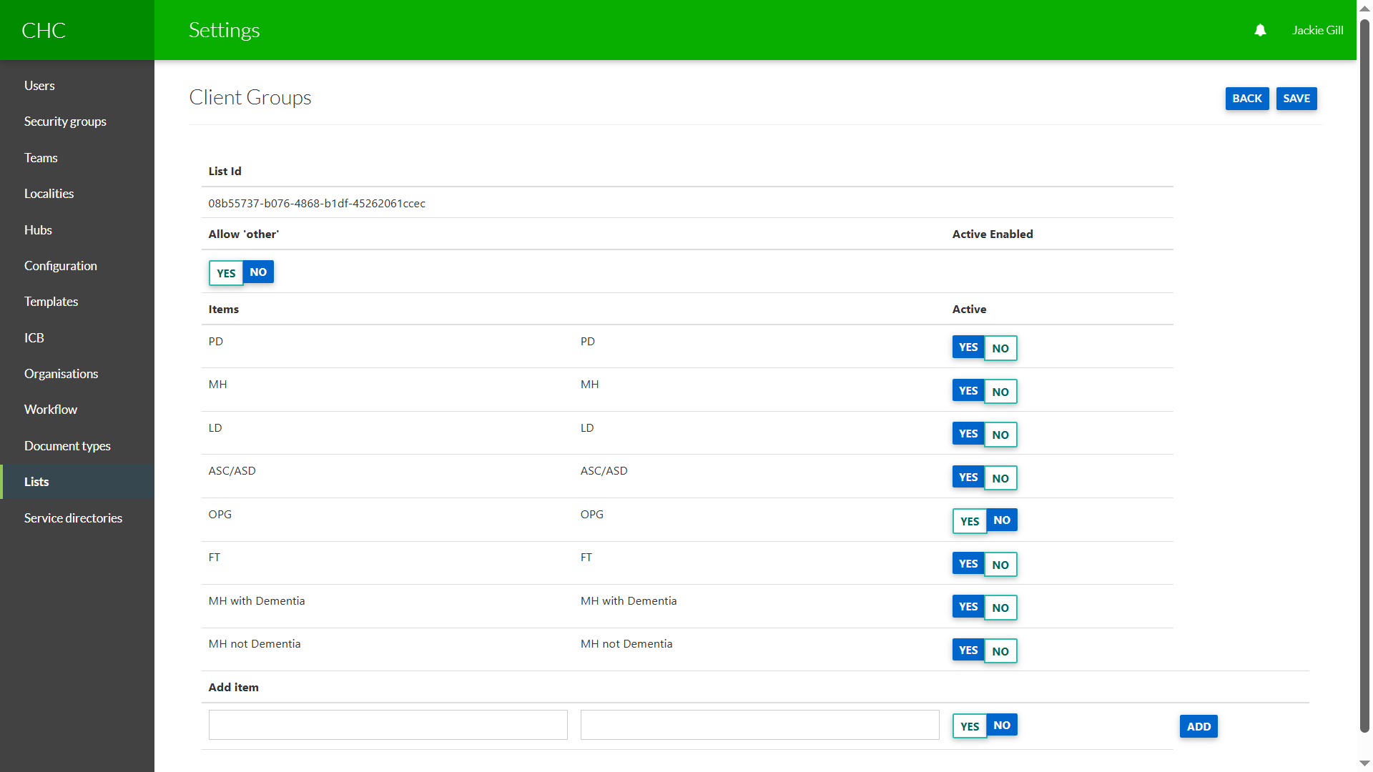

Please note if you wish to continue to record Primary Diagnosis for Client Groups MH and LD then please do not make those Client Groups inactive.

- The Client Group is a mandatory drop-down option on the digital referral forms:
  - Checklist
  - Fast Track
  - CYP Checklist
The Client Group drop-down field is on the Patient page of the referral forms underneath the NHS number:
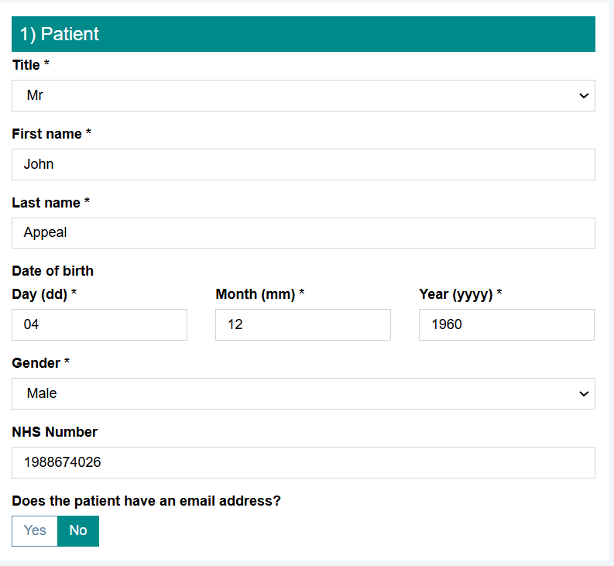
Checklist:
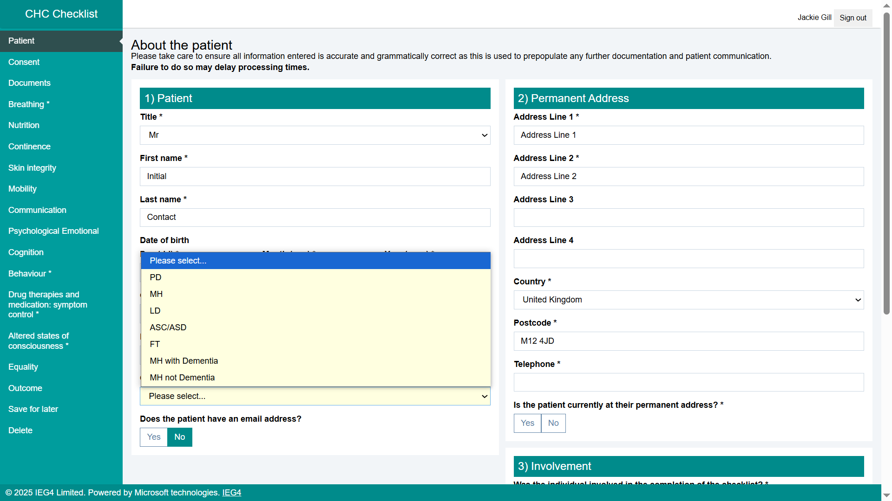

Fast Track:
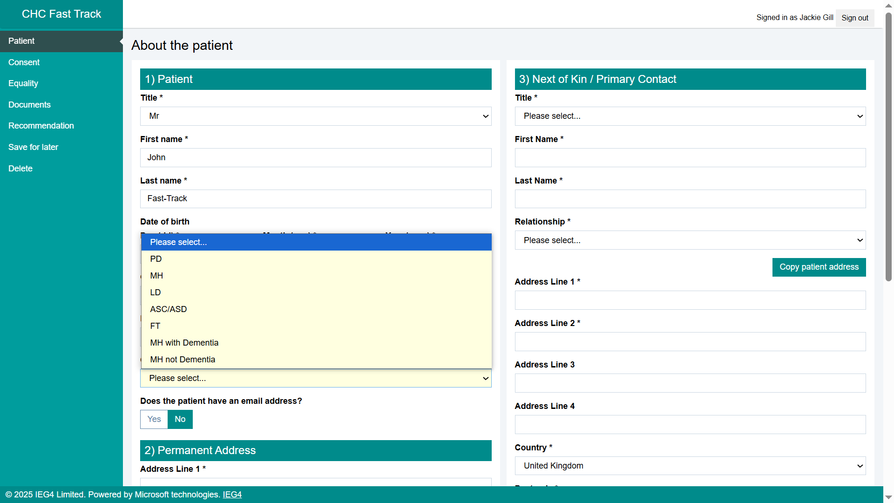
CYP Checklist:
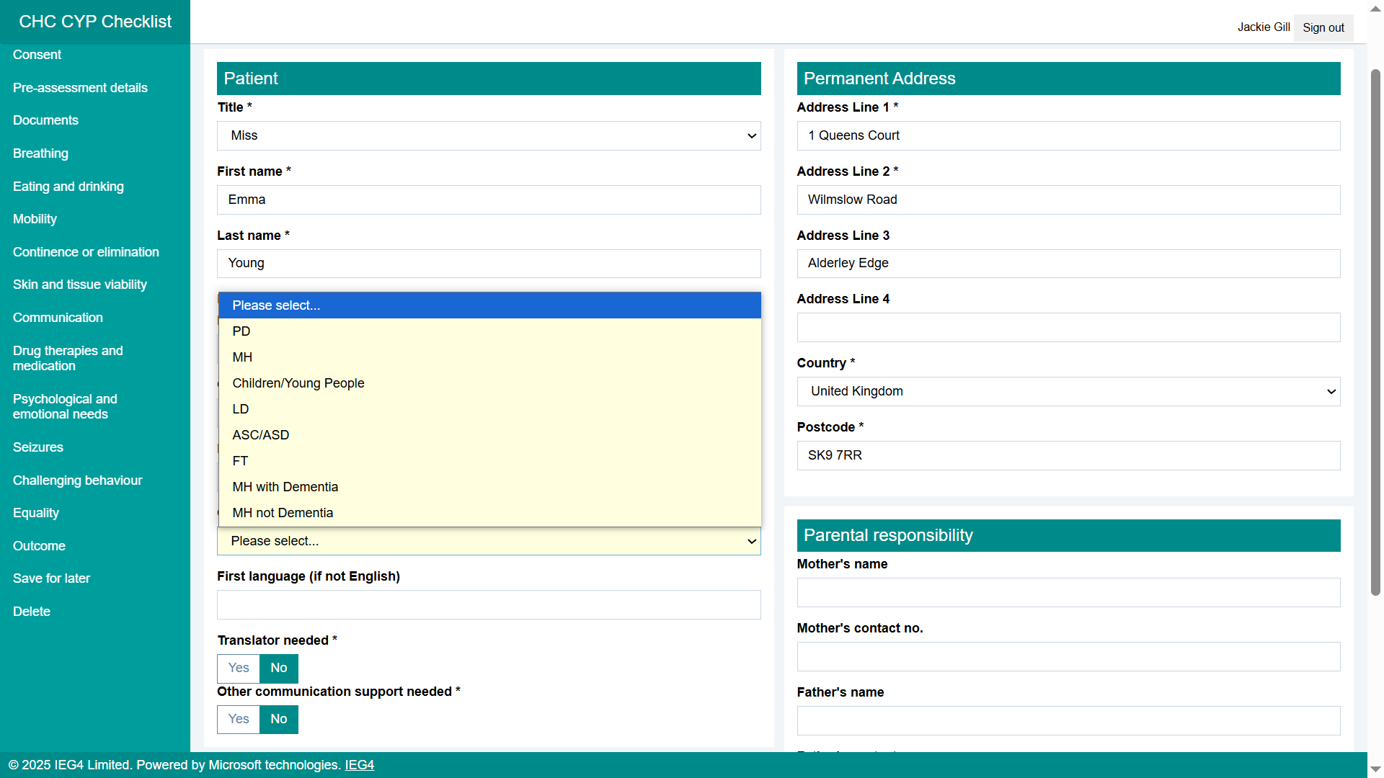
Client Group displays on Patient Summary when form submitted:
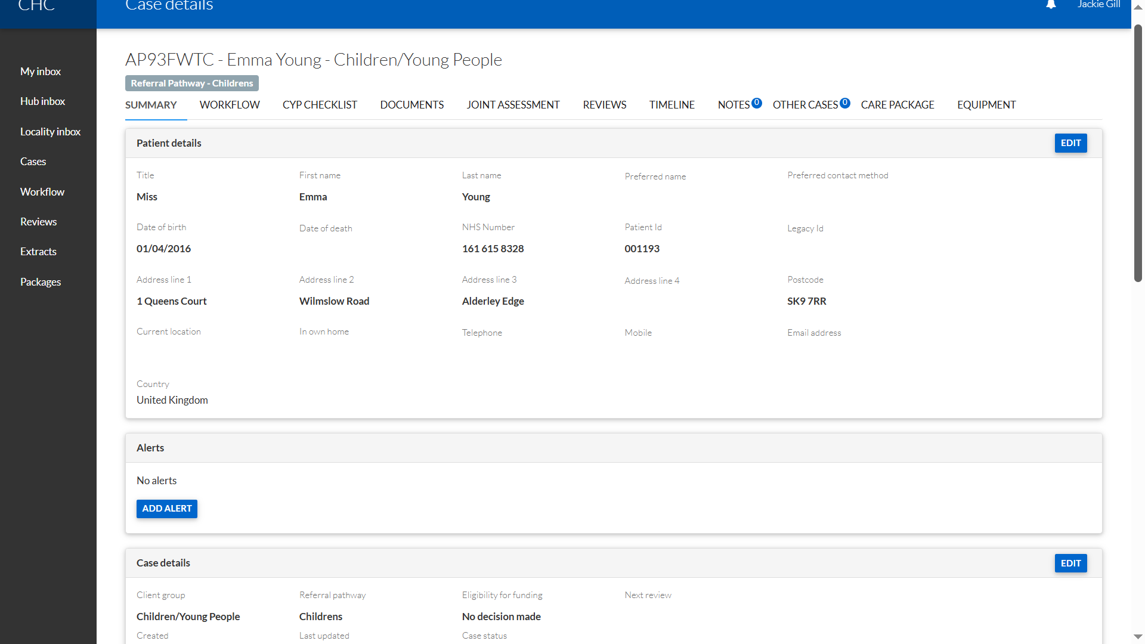

- The Mental Health Referral form already had a drop-down for Client Group. That form uses a separate list of the two options (Mental Health or Learning Disability), so no change was needed.

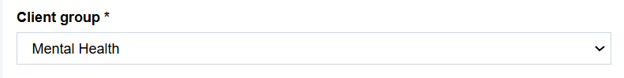

The Client Group selected on this form prepopulates the Client Group on the Summary tab of the case:

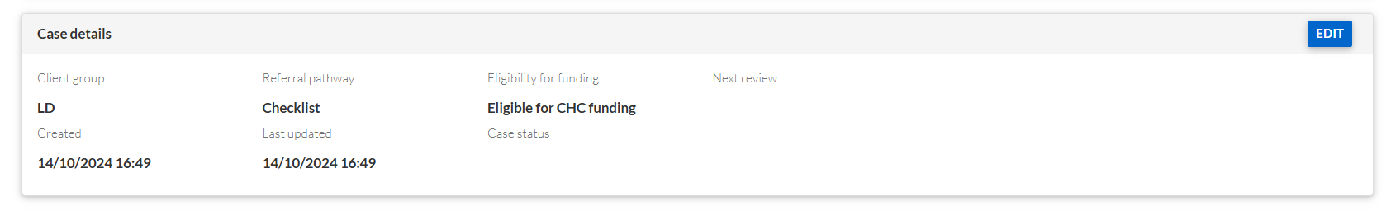

Client Group is now a drop down option on the Patient page:

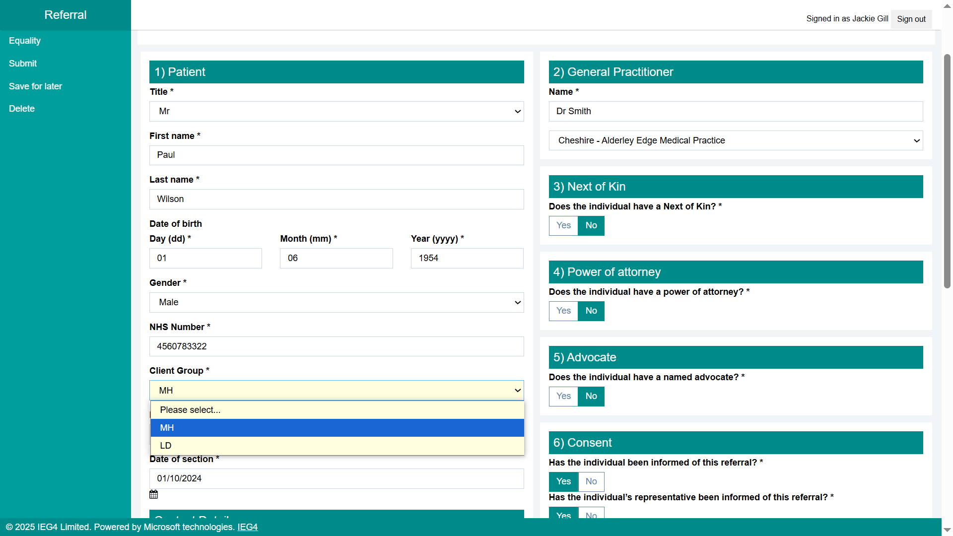

- The Notification of Admission form already has a question “Please select the relevant ‘Category of Care’. That list of options will now use the new configurable List of Client Groups:

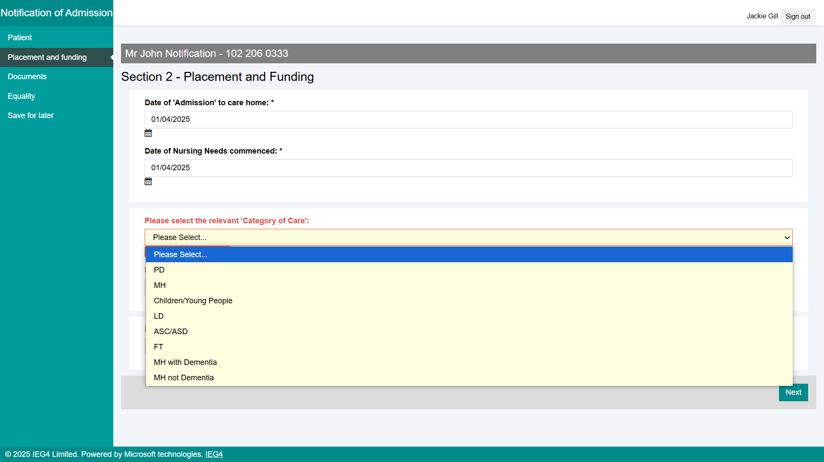

The Client Group selected on this form prepopulates the Client Group on the Summary tab of the case:

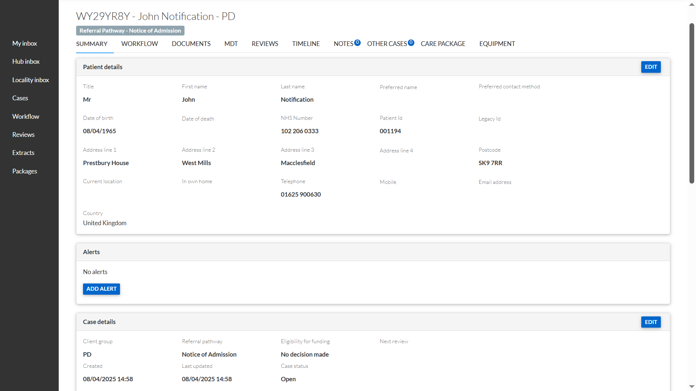

- The Care Group field has been removed from the MDT Recommendation stage of the Decisions Workflow (as this is now being captured earlier on):

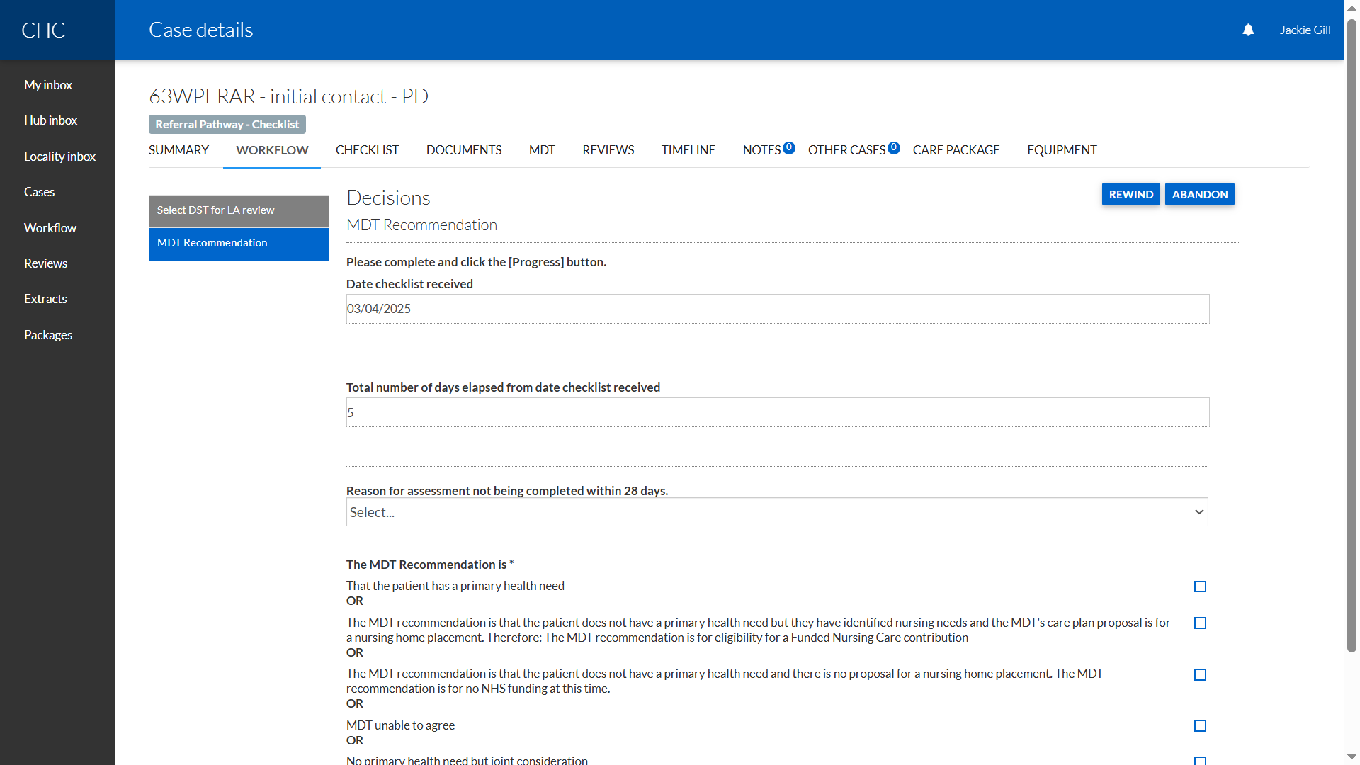

- The Care Group from Lists in Settings is no longer to be used (this has been replaced by the new Client Group List):

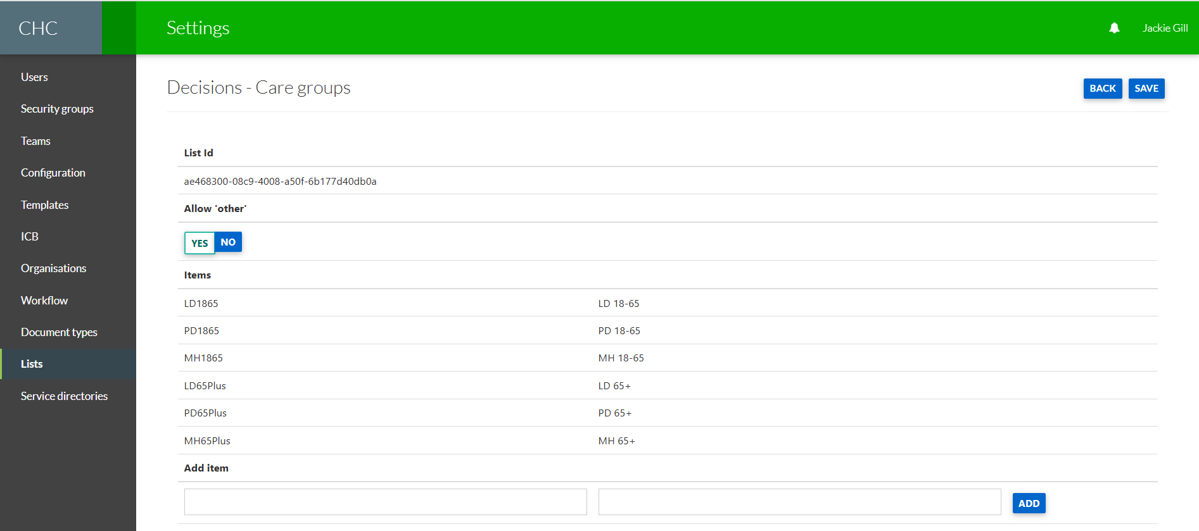

- The system displays the Client Group as a tag underneath the Case Reference and Patient’s Name:

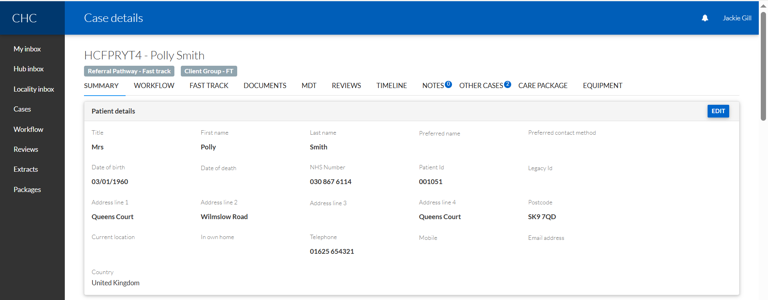

- We have re-labelled the “Which term best describes the individual” field to be “Client Group” in the Complete Care Package stage of the following Workflows:

  - Care Package Approval
  - Fast Track Care Package Approval
  - CYP Care Package Approval
  - FNC Care Package Approval
  - S117 Aftercare Care Package Approval

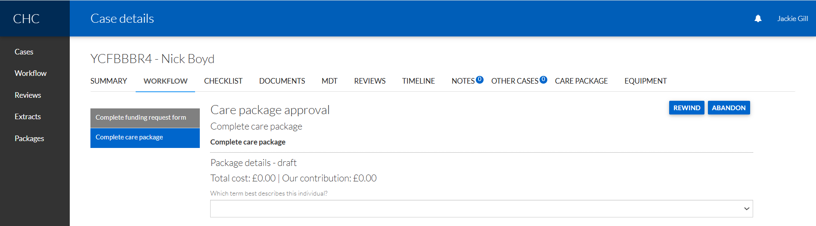

- The Client Group field is prepopulated with the Client Group that has been previously captured earlier on in the process) in the Complete Care Package stage in the following Care Package Approval Workflows:

  - Care Package Approval
  - Fast Track Care Package Approval
  - CYP Care Package Approval
  - FNC Care Package Approval
  - S117 Aftercare Care Package Approval

The Client Group options for MH or LD still controls whether Primary Diagnosis needs to be captured (as it does now).

- The Funding Review stage of the Care Package Approval Workflows is displaying the Client Group:

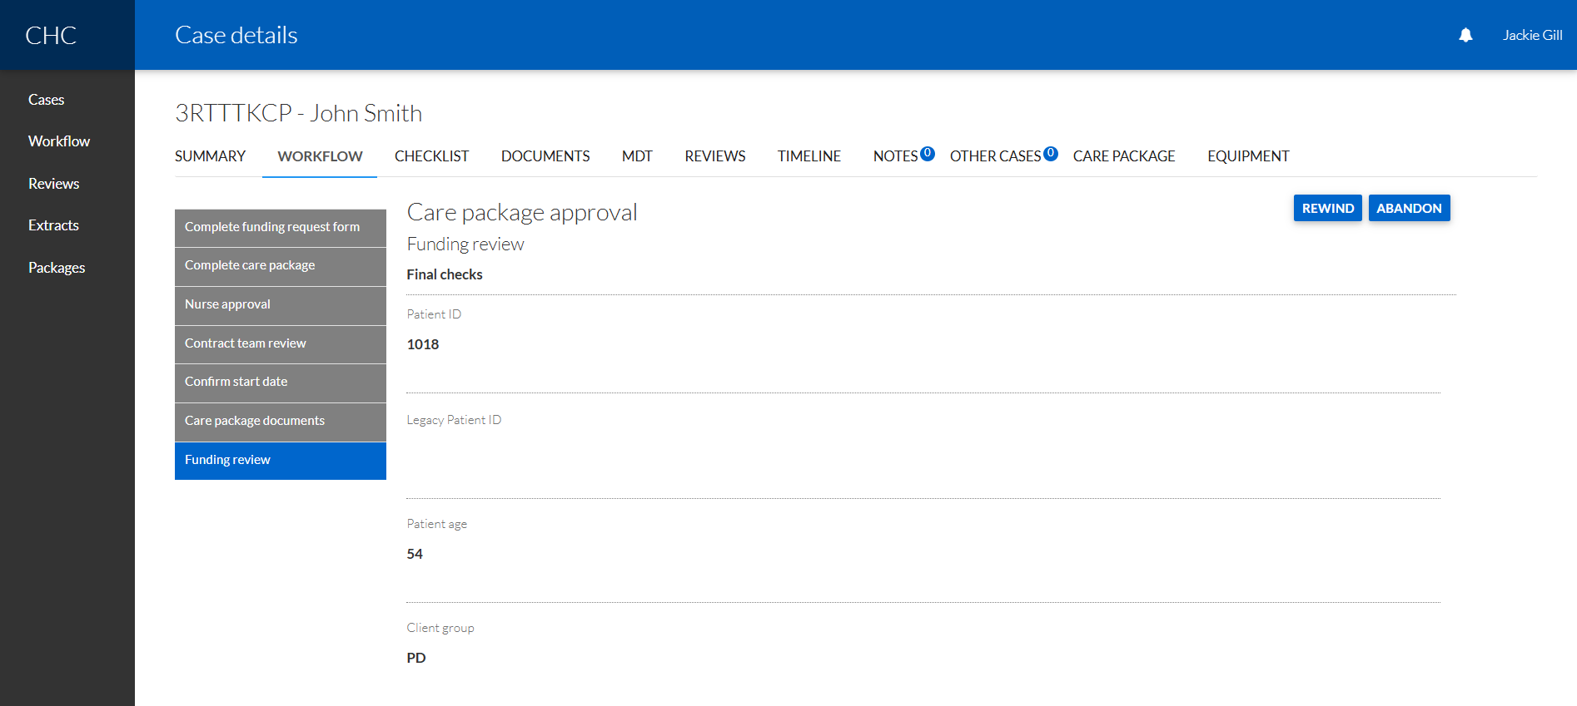

- The Client Group is editable on the Patient Summary page.

